**Predictive Modeling for Disease Diagnosis: Malarial Cell Detection**

## A PROJECT REPORT

***Submitted by***

## Shreshth Sahay 21BCS5409

## B. Venu Gopal Reddy 21BCS5361

***in partial fulfillment for the award of the degree of***

## BACHELOR OF ENGINEERING

### IN

##### COMPUTER SCIENCES AND ENGINEERING WITH SPECIALIZATION IN ARTIFICIAL INTELLIGENCE AND MACHINE LEARNING



### Chandigarh University

April 2024



### BONAFIDE CERTIFICATE

Certified that this project report **“** **Predictive Modeling for Disease Diagnosis: Malarial Cell Detection”** is the bonafide work of **Shreshth Sahay 21BCS5409; B. Venu Gopal Reddy 21BCS5361”** who carried out the project work under my/our supervision.

**SIGNATURE** **SIGNATURE**

Mr. Aman Kaushal Mr. Prabjot Singh Bali

**HEAD OF THE DEPARTMENT** **SUPERVISOR**

Associate Professor

Department of AIT- CSE Department of AIT- CSE

Submitted for the project viva-voce examination held on 30th April, 2024.

**INTERNAL EXAMINER EXTERNAL EXAMINER**

### TABLE OF CONTENTS

List of Figures ............................................................................................................ i

List of Tables ............................................................................................................ ii

Abstract ................................................................................................................... iii

Graphical Abstract ................................................................................................. iv

Abbrevations ............................................................................................................. v

Chapter 1. ................................................................................................................ 9

Chapter 2. ................................................................................................................18

### 2.1…………………………………………………………………………..…..18

### 2.2…………………………………………………………………………..…..30

### 2.3…………………………………………………………………………..…..31

### 2.4…………………………………………………………………………..…..41

### 2.5…………………………………………………………………………..…..49

### 2.6…………………………………………………………………………..…..51

Chapter 3. ................................................................................................................53

### 3.1…………………………………………………………………………..…..51

### 3.2…………………………………………………………………………..…..53

### 3.3…………………………………………………………………………..…..58

Chapter 4. ………………………….………………………………………........... 67

Chapter 5. ………………………………………………………………………… 73

References ................................................................................................................75

### List of Figures

**Figure 1.1 The Dipstick method ……………………………………………………………..…11**

**Figure 3.1 Methodology ……………….……………………………………………………….40**

**Figure 3.2 Dataset………………………………………………………….……………………41**

**Figure 3.3 EfficientNetV2L Architecture …………………………………………………..…46**

**Figure 3.4 MobilenetV3L Architecture …………………………………………………….…49**

**Figure 3.5 InceptionResnet Architecture …………………………………………………….52**

**Figure 4.1 EfficientNetV2L Accuracy……………..……………………………………….…55**

**Figure 4.2 EfficientNetV2L Loss …………………..………………………………………...55**

**Figure 4.3 MobilenetV3L Accuracy …………………………………………………………..56**

**Figure 4.4 MobilenetV3L Loss ………………………………………………………….……56**

**Figure 4.5 InceptionResnet Accuracy ..…………………………………………….….…… .57**

**Figure 4.6 InceptionResnet Loss …………………………………………………….….……..57**

**Figure 4.7 Testing ……………………………………………………………………….……....58**

### List of Tables

**Table 2.1 Methodology ……………………………………………………….32**

**Table 3.2 Methodology’s Accuracy …………………………………………... 36**

**ABSTRACT**

Malaria, a parasitic disease transmitted through the bite of infected mosquitoes, continues to pose a significant global health threat, especially in regions with limited access to healthcare resources. Timely and accurate diagnosis of malaria infection is paramount for effective treatment and prevention of the disease. However, traditional diagnostic methods like microscopy have inherent limitations in sensitivity and often require skilled personnel, leading to delays in diagnosis and treatment initiation.

In response to these challenges, this report introduces an innovative approach to malaria diagnosis by harnessing the capabilities of deep learning techniques. Specifically, convolutional neural networks (CNNs) are employed to develop a predictive model capable of identifying malaria-infected cells in microscopic images of blood smears with high accuracy and efficiency.

The methodology employed in this study involves rigorous preprocessing of image data, incorporating augmentation techniques to enhance the model's ability to generalize across diverse samples. Subsequently, a CNN architecture is meticulously designed and trained using a sizable dataset of annotated malaria cell images. To further optimize performance, transfer learning techniques are explored, leveraging pre-trained models to effectively utilize limited data and improve overall model performance.

The evaluation of the proposed deep learning model encompasses a comprehensive set of performance metrics, including accuracy, sensitivity, specificity, and the area under the curve (AUC) of the receiver operating characteristic (ROC) curve. Through comparative analysis with existing diagnostic methods, the efficacy and efficiency of the developed deep learning approach are thoroughly assessed.

The results of this study demonstrate promising outcomes in terms of both accuracy and efficiency, highlighting the potential of deep learning-based methods for malaria diagnosis. Moreover, the scalability and adaptability of the proposed approach indicate its suitability for deployment in resource-constrained settings, thereby offering a viable solution for improved disease management and control.

**GRAPHICAL ABSTRACT**

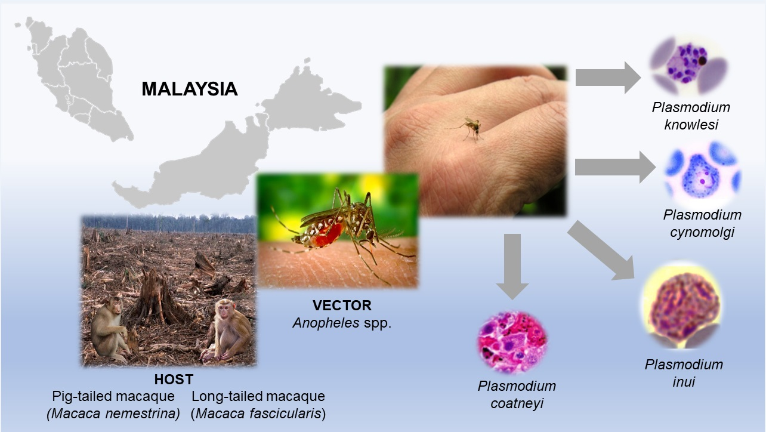

**ABBREVIATIONS**

1. RDT: Rapid Diagnostic Test
2. PCR: Polymerase Chain Reaction
3. WHO: World Health Organization
4. G6PD: Glucose-6-Phosphate Dehydrogenase
5. ACT: Artemisinin-Based Combination Therapy
6. LLIN: Long-Lasting Insecticidal Net
7. IRS: Indoor Residual Spraying
8. Pf: Plasmodium falciparum (species of malaria parasite)
9. Pv: Plasmodium vivax (species of malaria parasite)
10. Pm: Plasmodium malariae (species of malaria parasite)
11. PoC: Point of Care
12. ITN: Insecticide-Treated Net
13. SP: Sulfadoxine-Pyrimethamine
14. AL: Artemether-Lumefantrine
15. DHA-PPQ: Dihydroartemisinin-Piperaquine
16. AMA1: Apical Membrane Antigen 1
17. MSP: Merozoite Surface Protein
18. ELISA: Enzyme-Linked Immunosorbent Assay
19. IRBC: Infected Red Blood Cell
20. MDA: Mass Drug Administration

**CHAPTER-1**

**INTRODUCTION**

The World Health Organization (WHO) estimated in its World Malaria Report 2018 that there were 212 million malaria patients worldwide, resulting in approximately 435,000 deaths. Tropical Africa, in particular, experiences significant economic losses, amounting to an estimated 3.1 billion US dollars annually due to increased public health expenditures, impacting tourism. Malaria, caused by the Plasmodium parasite, spreads through the bites of female Anopheles mosquitoes but cannot be transmitted directly from person to person. Transmission can occur through blood transfusions, sharing syringes, or from mother to fetus.

Symptoms of malaria often resemble those of the flu and may include high fever, chills, septicemia, pneumonia, gastritis, enteritis, nausea, vomiting, and, in severe cases, death. Malaria primarily thrives in regions with hot, humid climates near natural water sources, which serve as the breeding grounds for Anopheles mosquitoes.

The diagnostic method for malaria typically involves a centrifuge machine separating white blood cells and red blood cells, with only the latter being used for analysis through a blood film. This standard laboratory method, known as the dipstick method, includes thick and thin blood smears. Microscopy-based detection of malaria provides insights into the extent and species of infection, aiding in both diagnosis and treatment monitoring.

Prompt diagnosis allows for immediate treatment with antimalarial agents such as Chloroquine, Doxycycline, Quinine Sulfate, Hydroxychloroquine, and Mefloquine. Thick and thin blood smears, which reveal various features of infected red blood cells (RBCs) such as color, size, texture, morphology, and parasite position, remain the preferred diagnostic method due to their affordability and widespread availability in clinics, hospitals, and medical laboratories.

The dipstick method, illustrated in Figure 1, serves as an effective means of malaria diagnosis, contributing to timely treatment interventions and disease management.

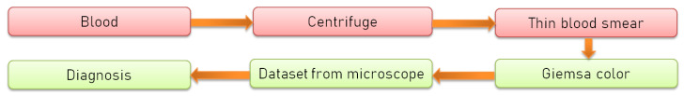**Fig -1.1 The dipstick method**

The methods employed conduct deep investigations of blood smears by using a microscope, providing images of patient blood to doctors or medical laboratory technologists to find parasites in red blood cells (RBCs). Deep learning, a subset of biologically inspired machine learning methods, aims to mimic the information processing and decision-making functions of the human brain. Convolutional neural networks (CNNs), a class of deep neural networks, are particularly suited for image analysis due to their shared-weights architecture and translation invariance characteristics.

To enhance the effectiveness of learning in CNN models, several factors are considered, including model weight initialization, data augmentation, dropout regularization, and hyperparameter tuning. Large datasets are essential for training CNN models to learn complex feature patterns and achieve appropriate classification performance. Techniques such as transfer learning and hyperparameter adjustment methods help reduce learning time, enabling efficient learning from small- to medium-sized datasets.

Previous research has applied CNN models to diagnose malaria-infected blood cells, aiming to develop computer-aided diagnosis (CAD) systems to aid in patient screening and reduce the workload of practitioners. Various CNN architectures, activation functions, and optimizers have been explored to improve model performance. For instance, using Mish activation function and Nadam optimizer has shown promising results in achieving higher accuracy in malaria cell detection.

Research efforts have also focused on fine-tuning pre-trained CNN models, incorporating techniques such as cyclical learning rates and support vector machines (SVMs) to determine stages of parasite infection. By leveraging pre-trained CNN models and transfer learning techniques, training time can be reduced while maintaining or even improving classification performance.

The proposed research aims to further enhance CNN models for malaria detection by employing Xception architecture with Mish activation function and Nadam optimizer. Preliminary results demonstrate a high accuracy of 98.86% on malaria detection tasks, indicating the feasibility of employing the developed deep learning model for malaria detection.

Malaria, a potentially fatal disease caused by parasites of the genus Plasmodium, is transmitted to humans through the bite of infected female mosquitoes of the genus Anopheles. According to the World Health Organization (WHO), there were an estimated 247 million cases worldwide in 2021, resulting in 619,000 deaths. Early diagnosis and treatment are crucial in reducing morbidity and mortality rates associated with malaria.

Various methods are available for malaria diagnosis, including the gold-standard method of microscopic examination of stained blood smears (thick drop), rapid diagnostic tests, polymerase chain reaction, and flow cytometry. Each method has its advantages and limitations, such as time consumption, cost, and expertise required.

In recent years, computational strategies have emerged to improve malaria diagnosis, particularly in supporting decision-making during microscopic examination. While many studies have focused on fine blood smear images, fewer have addressed thick blood smears, which present challenges due to sample concentration. Additionally, existing approaches often overlook the importance of detecting both parasites and leukocytes to estimate parasite density accurately.

To address these challenges, we propose an automated approach for detecting parasites and leukocytes in thick-drop images to aid in malaria diagnosis. Our approach leverages deep learning to detect parasites and leukocytes and estimates parasite density based on malaria diagnostic guidelines. We compared the performance of our model with that of malaria experts, demonstrating high agreement between results. Furthermore, our model outperformed malaria experts in terms of speed and accuracy in reading and counting parasites in image packets.

Malaria, caused by Plasmodium parasites transmitted through infected female Anopheles mosquitoes, poses a significant global health threat. With approximately 3.2 billion people at high risk of malaria each year, timely diagnosis and treatment are essential. The World Health Organization reports millions of malaria cases annually, predominantly concentrated in the African Region, Southeast Asia Region, and Eastern Mediterranean Region. Symptoms include fever, fatigue, headaches, and in severe cases, seizures and coma. Despite being preventable and treatable, malaria remains a leading cause of death, especially in developing countries. Early detection is critical for saving lives, underscoring the need for effective and timely diagnostic methods.

Traditionally, malaria diagnosis relies on blood samples examined under a microscope, a labor-intensive process performed by trained pathologists. However, this method is time-consuming and subject to errors, including false-positive and false-negative results. The process must be automated to improve accuracy and efficiency. The proposed approach should accurately identify parasites and provide consistent interpretations of blood films while reducing the burden on healthcare workers.

Deep learning algorithms, particularly convolutional neural networks (CNNs), have revolutionized various fields, including biomedical image analysis. CNNs excel at extracting features from input data, making them ideal for image classification tasks. In biomedicine, deep learning has facilitated more accurate diagnoses and personalized therapies. Medical data, including images, audio, and text, can be analyzed using deep learning techniques to derive insights for disease treatment and prevention.

Malaria diagnosis has seen advancements, but manual microscopy remains prevalent, limiting throughput and accuracy. Automated systems, driven by artificial intelligence, offer a solution by providing reliable and efficient diagnostic tools. In this study, we propose a VGG-based model for identifying infected cells, showcasing its effectiveness compared to existing models. The model's simplicity in design allows for efficient resource utilization while achieving high accuracy metrics.

Human malaria caused by Plasmodium falciparum is a mosquito-borne infectious disease threatening the lives of millions of people around the world. The World Health Organization (WHO) estimates that there were 212 million malaria cases globally in 2017, with 429,000 resulting in death. Of these, 90% of cases and 92% of deaths occurred in Africa, predominantly in sub-Saharan regions (with 76% and 75% of global cases and deaths occurring in only 13 countries). Around the world, children under 5 years-of-age are the most vulnerable, accounting for an estimated 70.6% of all malaria deaths in 2016. While various control and preventative interventions have been implemented over time, malaria still poses one of the greatest threats to human life.

An important set of control measures are the surveillance and estimation of burden of disease, to allow for strategic planning of already scanty healthcare and public health resources across endemic regions. Although the transformation of malaria surveillance into a core intervention has been designated as one of the three pillars of the Global Technical Strategy for malaria 2016–2030 (GTS), current surveillance and predictive systems are inadequate at accurately capturing and estimating the extent of malaria, particularly in highly endemic countries.

The need for predictive systems that can reliably estimate future burden of malaria disease is particularly important for well-defined Plasmodium falciparum malaria in heavily affected countries such as Nigeria in sub-Saharan West Africa. In Nigeria, the most populous country of Africa with 180 million inhabitants, the entire population is at risk of malaria (i.e. no malaria-free areas), with 76% of the population living in all-year-round high-transmission areas. Nigeria accounts for 29% of worldwide malaria cases and 26% of deaths in 2015 (mostly in children under five years of age), the largest proportion from any one country. This global health challenge is particularly striking in large urban densely populated cities such as Lagos (> 15 million inhabitants) and Ibadan (> 3.5 million inhabitants) both under large all-year-round malaria burden where stretched healthcare resources will benefit from advance knowledge of malaria prevalence to support their specific malaria clinical care pathways

Malaria is spread through the bites of female Anopheles mosquitoes infected with Plasmodium protozoan parasites, which infect red blood cells and cause them to swell and swell up. Every year, 3.2 billion people worldwide are at high risk of developing malaria, according to the World Health Organization. According to a survey conducted by the World Health Organization [1], 91 countries recorded 216 million cases of malaria. The World Health Organization is a nongovernmental organization that promotes health worldwide. Global malaria cases were primarily concentrated in the African Region, which was then followed by the Southeast Asia Region and the Eastern Mediterranean Region. The symptoms of malaria are often associated with fever, tiredness, headaches, and, in extreme cases, seizures and coma, all of which can be fatal if not treated promptly. Malaria is a preventable disease that can be controlled with adequate treatment. There is, however, no effective immunization available at this time. Once infected, it is a disease that progresses at a rapid pace. Malaria is a significant load on our healthcare system, and it is the top cause of death in many developing and developing-country populations. It is endemic in many parts of the world, which means that the disease is met on a regular basis in those areas of the world. As a result, early detection and treatment of malaria are essential in order to save lives. Because of this, we are motivated to increase the effectiveness and timeliness of malaria diagnostics in the future. Specialized technology is required in order to resolve this problem. As a result, it is vital to obtain a prompt diagnosis. The most important task in diagnosing malaria is to determine whether or not parasites are present. The most common method of diagnosing malaria is by the use of a blood sample. In the United States alone, millions of blood samples are tested for malaria each year, with a trained pathologist painstakingly counting parasites and infected red blood cells in each sample. According to the World Health Organization regulation [2], the blood smear should be inspected under a microscope at a magnification of 100x. Diagnostic treatments such as light microscopy and rapid diagnostic tests are two of the most often performed (RDT). The use of these two tests is typical in situations where high-quality microscopy services are not readily available. However, there are several disadvantages to using these procedures, including the fact that the diagnosis is primarily dependent on the pathologist's knowledge and skill, the possibility of false-positive and false-negative diagnoses, which can result in the development of other illnesses, and the fact that they are time-consuming, to name a few.

Late or incorrect diagnosis is the leading cause of death in the United States. As a result of the severity of this global health concern, it is important that the evaluation process be automated. The proposed approach must be capable of identifying parasitemia while also providing a more trustworthy and consistent interpretation of blood films, among other things. It must be cost-effective and alleviate the load placed on malaria field workers and their families.

In today's world, deep learning algorithms are commonly used to classify photos, recognize films, and analyze medical images, among other things. Convolutional neural networks (CNNs), a kind of deep neural networks, are the neural networks that are most commonly utilized in the field of computer vision. Specifically, in the field of biomedicine, deep neural networks have been demonstrated to be the most effective machine learning technology available. Due to the ease of extraction of crucial information and completion of tasks that were previously difficult to complete using conventional approaches, deep learning (DL) has become highly popular in the recent decade for evaluating and diagnosing biomedical and healthcare problems. The convolutional layer of the CNN serves as an automatic feature extractor, extracting both hidden and important properties from the input data. Image categorization is accomplished by the use of a fully connected neural network, which optimizes probability scores by feeding the retrieved features into the network. Additionally, when deep learning is used in biological applications, the number of research articles published has increased significantly over the past several years. There are three broad categories of applications for machine learning in biomedical applications: (1) as a computer-aided diagnosis to assist physicians in making more accurate and timely diagnoses, with improved harmonization and fewer contradictory diagnoses; (2) to improve patient medical care through more personalized therapies; and (3) to improve human wellbeing, for example, through the analysis of disease spread and social behavior in relation to environmental factors [3]. Medical devices and equipment are now capable of producing vast amounts of data, which can include photos, audio, text, graphs, and signals, among other types of information. Using a machine learning technology known as deep learning, this medical data may be analyzed [4]. Deep learning is a technique that consists of layers of comparable functions cascading down through the network. Deep-learning algorithms can mine massive amounts of healthcare data in search of information that can be used to aid in the treatment and prevention of diseases and ailments. Deep-learning algorithms can mine massive amounts of healthcare data in search of information that can be used to aid in the treatment and prevention of diseases and ailments. People who are knowledgeable in the machine learning area recognize the global impact that deep learning is having by investigating and resolving human problems across all fields, despite the fact that deep-learning applications may appear disillusioning to the general individual.

A fatal disease, malaria affects hundreds of millions of people each year all over the world, and it is preventable. If it is not treated immediately, it can be fatal. Although there have been significant advancements in malaria diagnosis, the microscopy approach continues to be the most extensively employed. Unfortunately, the accuracy of microscopic diagnostics is dependent on the expertise of the microscopist, resulting in a limitation in the throughput of malaria diagnosis. Manual microscopy has been proved to be an unreliable screening method when conducted by nonexperts due to a lack of training, which has been demonstrated in several investigations, particularly in rural areas where malaria is endemic. An automated system's mission is to do this activity without the need for human interaction, and it should do so by providing a goal-oriented, dependable, and efficient tool to accomplish this. It is now possible to minimize expenses while simultaneously enhancing overall accuracy because of the advent of artificial intelligence tools, notably deep-learning techniques. In this study, we present a VGG-based model for recognizing infected cells, and we compare it to previously created models in order to demonstrate its effectiveness. Our model outperforms the majority of previously produced models over a wide range of accuracy metrics. The model has the advantage of having a modest number of layers because it was constructed in this manner. Thus, the number of computing resources and computational time required are kept to a minimum.

Malaria, a disease caused by the Plasmodium parasite and transmitted through mosquito bites, continues to pose a significant global health threat, with an estimated 219 million cases documented in 2017. In response, the World Health Organization (WHO) initiated a comprehensive strategy with the goal of eradicating malaria by 2030. Despite successful control efforts in various regions of China over the years, accurately predicting malaria outbreaks remains a formidable challenge.

Conventional prediction techniques like linear regression and ARIMA models, while valuable, are constrained by their assumptions regarding linear correlation structures within time series data. Deep learning algorithms, including back-propagation (BP) neural networks and long short-term memory networks (LSTM), present promising alternatives by adeptly capturing intricate data patterns. Moreover, stacking architectures, which amalgamate diverse prediction models, offer potential for further enhancing predictive accuracy.

In our investigation, we scrutinize malaria incidences across China from 2007 to 2017, juxtaposing conventional time series models against deep learning methodologies. Furthermore, we delve into the utility of stacking techniques in malaria prediction endeavors. Our study encompasses a comprehensive examination of data sources, detailed methodology descriptions, empirical findings, delineation of limitations, and conclusive insights. By doing so, we endeavor to contribute to the refinement and advancement of malaria prediction strategies.

Expanding upon this discourse, it is imperative to underscore the multifaceted nature of malaria prediction and surveillance. Effective malaria control necessitates a nuanced understanding of various contributing factors, including environmental conditions, vector behavior, and human demographics. Harnessing advanced computational techniques such as deep learning offers promise in unraveling the complexities inherent in malaria dynamics.

Moreover, the integration of stacking architectures underscores the importance of leveraging diverse prediction models to yield robust and reliable predictions. By amalgamating the strengths of different methodologies, stacking approaches can mitigate individual model limitations and enhance overall prediction accuracy

**CHAPTER-2**

**LITERATURE SURVEY**

**2.1.** **Timeline of the Reported Problem**

Malaria cells identification and sorting has gone through a number of transformations. The research initially concerned the microscopic analysis of the blood samples which began with the discovery of the malaria's parasite by Sir Ronald Rossin 1897. In the twentieth century, between the know-how of microscopy methods, staining, and the malaria biological field's advanced understanding appears as tool that is useful in detecting malaria accurately.  
  
 In the last decades of the 20th century and the early 21st century, the development of computational techniques and machine algorithms revolutionized the way cells responsible for malaria could be recognized. The scientists shifted from studying traditional digital images to investigating pattern recognition algorithms, deep learning models and artificial intelligence technologies to improve malaria parasite detection.

Malaria is a mosquito-borne disease that has affected many people throughout the world. According to 2015 statistics, 214 million cases of malaria infection have been reported with an estimated 438,000 deaths worldwide. It is the most common syndrome that requires proper treatment at a very early stage. Early and effective diagnosis of malaria makes it both preventable and curable. The different stages of malaria-infected red blood cells (RBCs) are early and late trophozoite. In general, there is no change in size in the early trophozoite stage and two or more chromatin dots are present while the vacuolated and dark pigment is present in the late trophozoite study. To assess the impact of promising antimalarial drugs and to characterize the distinctive life-cycle phases of malaria parasites on the host cell invasion, parasite departure and schizont development. Such a framework will encourage current efforts to recognize new antimalarial drugs and antibodies that focus on the distinctive erythrocytic phases of Plasmodium falciparum (P. falciparum) parasites. Microscopic testing is the gold standard technique for the diagnosis of malaria due to its low cost and renowned method. Significant progress has been made over the last decades in the field of quantitative phase microscopy to overcome the limitation of traditional phase microscopy. Several quantitative phase imaging (QPI) methods such as digital holography quantitative phase microscopy/spectroscopy, optical diffraction tomography, refractive index tomography are used for the quantification of unstained malaria-infected RBCs. Although, all these techniques are very much successful in biomedical applications, they also have certain disadvantages. To capture the dynamic behavior of the biological cells such as membrane fluctuations, dry mass cell density, etc. Off-axis interferometry or holography is preferred since it gives complete information in a single shot, whose response solely depends upon the speed of the recording. However, coherent https://doi.org/10.1016/j.optlastec.2020.106335 Received 3 September 2019; Received in revised form 31 March 2020; Accepted 9 May 2020 Corresponding author. E-mail address: vishalsrivastav17@gmail.com (V. Srivastava). Optics and Laser Technology 130 (2020) 106335 0030-3992/ © 2020 Elsevier Ltd. All rights reserved. T noise and parasitic fringes formation due to highly spatially and temporally coherent light source (laser light) reduces the quality of images resulting in phase measurement inaccuracy. In order to overcome this problem, broadband light sources such as white light, and LEDs are generally used for those with a high spatial phase sensitivity due to low temporal coherence length. Due to low temporal coherence length, the interference will only occur when the path difference between the reference and sample arm is within the coherence length which limits the use of the entire camera field of view. Low fringe density also makes it difficult a single-shot phase recovery and therefore, a multi-phase-shifting algorithm is used for phase extraction at full detector resolution which limits its application for the study of the dynamic behavior of the cells. The other disadvantage with a broadband light source-based system is that it required chromatic aberration corrected optical components. However, these issues can be resolved with the use of high temporal and low spatially coherent light source. The significant advantage of this kind of light source (high temporal and low spatially coherent) that it has a high fringe density over the entire camera field of view and it doesn’t require any dispersion compensation mechanism. Therefore, this source is more suitable for the dynamic biological sample with a strong dispersion or inhomogeneous spectral response. The cells have different absorption, emission and scattering properties with respect to each wavelength. Using multi-wavelength imaging will helpful to extract the different information that is embedded in it. As refractive index is a function of wavelength and is directly correlated with structural and biomechanical characteristics of the sample

. In the past few years, several efforts have been made to use machine learning to automatically detect of malaria infection from microscopic images of stained blood cells in order to avoid human error in interpretation. Most of the machine learning methods such as K-NN, Naive Bayes, ANN, and SVM, etc. use shape measurement, color features and statistical features for the classification of RBCs infected with malaria but the achieved accuracy varies from 84 to 95% for the detection of parasites from stained blood cells. As discussed, although attempts are being made to automate the diagnosis of malaria on the basis of morphological features, its sensitivity and specificity due to overlapping color intensity make it difficult to classify early and late trophozoite as shown in Fig. 1. In the case of images, the primary source of information is the local spatial correlation among the neighboring pixels. In that case, CNN a class of deep learning (DL) will be a good option for the classification. In medical imaging analysis and interpretation CNN's, a branch of DL has an excellent record over other approaches. Thus this will become an obvious choice for the analysis of images. A different arrangement of the filters will lead to different architecture of CNN. The biomedical domain generally suffers from a limited amount of data and these data also contain high variability that will cause “overfitting”. Due to overfitting, the features can't generalize well on data and training DL model from scratch requires extensive memory and high computational power, which limits its application in the biomedical domain. To overcome this problem “transfer learning” and “finetuning” would be a good solution.

African countries got affected the most due to malaria. 92% of the global malaria deaths occur in Africa where, the children below 5 years accounted for two thirds of the malaria infected deaths. The typical malaria symptoms are fever, nausea, headaches and in severe cases, yellow skin, seizures, coma, which leads to death. Several millions of blood films are examined every year by trained experts for detection of malaria infection. The detection of malaria involves counting the parasites and infected red blood cells manually. However, it completely depends on experience and skill of the microscopist. While working in limited resource set-up with no system helpful for maintenance of the skill will affect the diagnostic quality. Which leads to wrong diagnostic decisions. Deep learning can be implemented in the classification of cell images which can prevent the wrong diagnostic decisions. Deep learning is an area of machine learning, which performed exceptionally well in many non-medical fields. The applications of deep learning have been limited in medical field due to lack of expert knowledge in that field and privacy concerns. But, in recent years deep learning was used in many medical fields.

Every year, hundreds of millions of blood films are examined for malaria, which involves a trained microscopy manually counting parasites and infected red blood cells (RBCs). Precise counts of parasites are not only essential for malaria diagnosis but it is also important for drug-resistant testing, measuring drug efficacy, and classifying the severity of the disease. However, Microscopic diagnostics are not standardized and strongly depend on microscopist’s experience and skills. In low-resource settings, it is usual for microscopists to work in isolation, with no rigorous system in place that can ensure the upkeep of their skills and therefore the diagnostic quality. That leads to wrong diagnostic decisions in the field. A misdiagnosis involves unnecessary use of anti-malaria drugs for false-positive cases and going to suffer from their possible side effects, such as abdominal pain, nausea, diarrhea, and sometimes severe complications. Therefore, the automated system became an important method for assisted diagnosis. A new technique related to machine learning neural network called deep learning is developing recently to achieve better performance on classification tasks. One such form of deep-learning method is the Convolutional Neural Network (CNN). It is on top of image classification and recognition tasks, and it has the capability to simulate human vision.

Deep learning, a branch of machine learning, has emerged as a powerful tool for classifying medical images. In recent years, deep learning-based models have been applied to a wide range of medical imaging tasks, including the classification of skin lesions, brain tumors, and lung cancer. With the availability of large datasets of microscopy images of malaria-infected blood cells, deep learning-based models have also been applied to classify malaria. Deep learning models, such as convolutional neural networks (CNNs) and deep belief networks (DBNs), have been trained to classify malaria-infected blood cells with high accuracy. These models have been trained on a large dataset of microscopy images of blood cells, and have been shown to be able to accurately classify the images as infected or not infected with the Plasmodium parasite. One of the key advantages of deep learning-based models is their ability to learn features from the data, which can be used to classify the images. CNNs, in particular, have been shown to be effective in this task, as they are able to automatically extract features from the images, such as the shape and texture of the cells, which are important for the classification of malaria. In addition to classification, deep learning-based models have also been applied to other tasks related to diagnosing malaria, such as the segmentation of infected cells in microscopy images and detecting the Plasmodium parasite in blood smears. These models have been trained on large datasets of images and have been shown to be able to accurately segment and detect the parasite, which can aid in the diagnosis of malaria. A deep learning-based model is a powerful tool for classifying malaria-infected blood cells. This model has been trained on large datasets of microscopy images and shows 273 JOIV : Int. J. Inform. Visualization, 7(2) - June 2023 273-278 accuracy in classifying the images as infected or not infected with the Plasmodium parasite. With the continuing advancement of deep learning-based models, it is expected that these models will play an increasingly important role in the future diagnosis and treatment of malaria. Malaria is classified as a disease generally experienced by humans due to the bite of a female Anophles mosquito carrying the plasmodium parasites, such as Plasmodium falciparum, Plasmodium vivax, Plasmodium malariae, and Plasmodium ovale. Malaria is considered a serious infection caused by peripheral blood parasites of the genus Plasmodium. Malaria is commonly acknowledged as a disease that often occurs in coastal areas. Malaria sufferers typically experience flu-like symptoms, high fever, chills, and headaches, attacking all demographic features (regardless of age and gender). Symptoms of malaria typically appear after ten days to 4 weeks in the form of fever, headache, vomiting, chills, anemia, and enlarged spleen. Hence, early detection of malaria-infected blood cells is deemed vital by monitoring blood cell counts annually by experts trained to detect malaria infection. Malaria detection involves manually counting parasites and infected red blood cells, which is highly dependent on the experience and skills of the microscope expert. As such, this expertise is highly prioritized; however, limited resources and systems could certainly affect the quality of diagnostics, leading to inappropriate diagnostic decisions. Prior studies have been devoted to discussing malaria cells, especially in the case regarding the classification of blood cells infected with malaria as conducted by Reddy and Juliet in 2019, aiming to obtain appropriate diagnostic results against microscopic malaria cells by employing the Convolutional Neural Network (CNN) method and the Resnet-50 architecture. In 2020, malaria-related research was also conducted by Sayyed et al. by observing the comparison of the effectiveness between convolutional combinations and neural networks to detect malaria parasites. In particular, the CNN method has been considered a popular method in two-dimensional processing data, with a similar grid topology utilizing convolution as a substitute for matrix application, which applies at least one convolution in each layer. CNN is considered a type of deep learning, a machine learning component to teach computers to conduct an activity such as the training process. Therefore, this method is effectively implemented for datasets that have a two-dimensional structure. In addition, this study aims to improve the performance of the proposed model, which is the Inception-V3 model, to obtain better accuracy performance results than those in previous studies.

"Wellbeing is rich," maybe an instant statement is really obvious all the time! All this means that regional unit planning is being monitored yet artificial intelligence is being used for the contamination of the site, a destructive illness and the construction of a reasonable, viable and appropriate code Objective of the PC document. Plasmodic parasites that are the estimate unit communicates by chomps of the tangled female class mosquitos can also cause contamination to be a dangerous irresistible mosquito-borne disease. There are 5 parasites, but two sorts — P. Falciparum and P. Vivax — which cause most of the illnesses in a unit of estimation. In the absence of a dipterone tear in the partner, a dipterone transported parasite enters your blood and begins to obliterate red oxygen platelets (RBC). The main manifestations of the pollution unit, like an infection, generally occur within a few days or weeks of the injury.In any event, these lethal parasites can stay longer than a year in your body despite providing little evidence and treatment delays may lead to complications and even death. Early detection may also save lives. Realities about the diseases of the Globe Wellbeing Organization (WHO) indicate that the entire population is at risk for infection in comparison to zero.5 and that their unit of measurement has been continuously polluted with more than 200 million cases and approximately four hundred thousand passages. This can usually be a daily inspiration in order to make the position and assignment of pollution quick, easy and convincing. AI is one of the areas in the common world of registration. The devices were made rational by a marvellous research arrangement. Learning may also be a normal human behaviour, and is now a main machine. Any residual manner produced for an undifferentiated unit of territory is produced. Conventional AI measurement zone unit applied in a few areas of use. For the exhibition of these AI equations, researchers have put a great deal of effort into them. There was an additional assessment of thinking that led to the likelihood of deep learning. Deep learning is a variety of AIs. Deep learning supports pioneers and adapters in all aspects of our daily lives. Numerous successes in applied science, which we will normally tuned to recognise on a stretch of the media square based on deep learning. The topic of applied science, which focuses on the development of huge models of neural organisations, is a deep-seated learning, which is suited to develop explicit information-driven decisions. Profound learning is especially ideal for circumstances where the data is unpretentious and large data sets are marketed. Today, the most online organisations and leading consumer developments use in-depth learning. In order to examine the text in online forums, Facebook uses the invention of profound learning, among other aspects. Google and Microsoft use each profound information for image search, as well as for figures. There is deep learning framework available on all stylish reasonable telephones. Deep learning, for example, is common for speech acknowledgement and, in addition, for facial position on computer cameras, as of now. Self-driving cars, News Complete & Ransom News Find, language strategy, Remote helpers, diversion, visual perception, emergency facilities and high usefulness of profound education through companies; High-Contrast images, sounds to silent movies, programmed figures, age of penmanship, programmed game teams, language interpretations, constituent reconstruction, segment and policy predictions. A large judgement of PC vision companies proved to be very effective across profound learning models or many directly convolutionary neural organisations (CNN). Continuing to show convolution and bundling layers of essential layers in a model CNN. The CNN, a class of falsified neural groups which predominated in changing PC vision companies, attracts attention across a range of fields, as well as radiology. Consequently, CNN can learn, adaptively and by abuse of various mechanisms, such as convolution layers, pooling layers and entirely linked layers, to incremental reflection frameworks of decision-making. In a wide range of computer vision activities, the Deep Learning models or, more specifically, the CNNs have proved to be truly accurate. Briefly, as seen in the following diagram, the main layers in a CNN model involve convolution and pooling.

Convolution layers benefit from the details spatially streamlined patterns that are invariant in translation. They are also ready to learn completely new aspects of photographs. For instance, small and native patterns such as boundaries and corners can be learned from the primary convolution layer, the second convlation layer can learn broader patterns assisted by primary layer options and then by. This enables CNNs to simplify feature engineering and create powerful options to generalise new points of expertise. Pooling layers make sampling and reduction in size easier. Therefore, CNNs make U.S. function engineering machine-controlled and scalable. Plugging thick layers at the tip of our model often helps the US to accomplish tasks like classifying pictures.

Medically, malaria can be diagnosed by means of patients’ blood test and microscopy where blood is placed on a slide before a test is performed to find irregularity of red blood. This is a standard test to confirm malaria infection. There are five species of malaria parasites that commonly infect humans, namely Plasmodium vivax, Plasmodium falciparum, Plasmodium malariae, Plasmodium ovale and Plasmodium knowlesi. In Thailand, Plasmodium falciparum and Plasmodium vivax, are the most frequent and widely distributed causes of malaria. At present, studies to discover tools for malaria diagnosis are widely conducted, especially analysis through digital image processing system for image data classification and malaria parasite recognition by means of Gray-Level Co-Occurrence Matrix (GLCM) feature extraction edge detection of malaria parasites, HSV color model using color histogram to construct image index in the classification process threshold, grayscale, and edge detection. These techniques and methods have been developed to classify image data and recognize malaria parasites up to today. Recently, convolutional neural network (CNN) have been developed by AlexNet, and face recognition algorithm is further developed with deep learning. Route exploration of natural environment (DNN), with prominent features of CNN algorithm, which can be used to extract main features of an image through filters in each convolutional layer to obtain important information of an image that can be used to effectively classify image data with k-nearest neighbor (KNN) algorithm technique. And from the Image classification of malaria using hybrid algorithms: convolutional neural… (Wisit Lumchanow) 383 importance of the problems mentioned above, the researcher has an idea to develop an automatic system for reliable classification of malaria and low cost using Digital Image Processing Techniques. In this paper is aimed at developing malaria parasite classification and recognition to enable accurate disease diagnosis with CNN for feature extraction and method to find appropriate k for KNN algorithm to improve the efficiency of detection of Plasmodium vivax, Plasmodium falciparum, to compare the test results of the proposed algorithm.

Owing to the rapid improvement of GPU computing power, neural networks are now able to grow into larger sizes in both width and depth. However, more layers bring an increasing number of parameters that need to be trained. For example, GoogLeNet has 6 million parameters, AlexNet has 62 million parameters, and VGG16 even has 138 million parameters. Researchers have been studying how to reduce the parameter size of neural networks and have successfully used different pruning methods to relieve the pressure of GPUs. In this paper, instead of fixating on the neural network, we investigated the feasibility of using the neural network to classify images in their compressed domain, which took much less storage and thus consumed less computing power. We evaluated different combinations of output from the JPEG lossy compression method. We calculated the DC values of each minimum coded unit (MCU), together with zero to five AC values after 2D discrete cosine transform (DCT) or quantization. We defined these datasets as the baseline because all the DCT coefficients were directly correlated to the pixel values from the original image. DC values after differential pulse-code modulation (DPCM) and variable length coding (VLC) were also extracted. For the compressed bitstream, two datasets were built from the scan segment in both decimal and binary numbers. Finally, the entire bitstream was represented in decimal and binary values. All the mentioned datasets were tested on a long short-term memory (LSTM) network.

Computer-aided diagnostic (CADx) tools have the potential to lessen the burden on healthcare staff by aiding in disease interpretation and diagnostic process using some machine learning (ML) algorithms applied to microscopic blood cell images. To overcome challenges of developing hand-engineered features that capture even the minute variations in the underlying data, deep learning (DL), also known as deep hierarchical learning, is widely used with significant success owing to its high accuracy. This paper, not being the subject’s first study paper, several study papers have been released before, bearing witness to automated diagnosis of malaria in blood smear images. Early detection of malaria is crucial to ensure appropriate diagnostic process and increase the chances of the patient being cured. Considering the severity of malaria by the amount of deaths caused by this illness, accepting possible negligible mistakes caused while execution by an automated method is justifiable. Deep learning techniques have advanced over the years and have proven to be much better than traditional methods as they ease the feature extraction process. Hence, in this paper we further utilize deep learning as a method and propose an approach using a Convolutional Neural Network (CNN) for detecting malaria from microscopic cell images using image classification. In this paper, we investigate two training approaches and compare both based on performance and select the better approach. We further evaluate our proposed model on testing set using metrics like F1 Score, AUC Score, Specificity and Sensitivity.

Global management of malaria is very difficult since early detection of malaria infection relies mostly on diagnosis using manual microscopy of Giemsa-stained infected cells. The disease is hard to detect, especially in rural areas and developing countries due to lacking of equipment and human resources. It is a cause of millions of deaths every year [1]. The disease is caused by parasites of the genus Plasmodium [2]. There are four species of Plasmodium: P.falciparum, P. vivax, P. ovale, and P. malariae. The direness of the disease is that its symptoms are similar to an ordinary cold, e.g., fever, headache, and vomiting. In this research, we aimed to focus on P.falciparum that is the most commonly found and dangerous disease in Thailand. P.falciparum causes anemia, The associate editor coordinating the review of this manuscript and approving it for publication was Carmelo Militello . coma, and progresses to death if correct treatment is not considered or the diagnosis comes in very late. The disease can be transmitted by female Anopheles mosquito. Infection occurs after a person was bitten by one of them. The malaria parasites—merozoites—expeditiously invade the host red blood cells (RBCs) then proceed to more developed forms. There are three stages of merozoites development that are Ring Form, Trophozoite, and Schizont (Figure 1). In the last stage, infected RBCs are filled with many Schizonts and burst open. Afterward, some merozoites will find some new RBCs and start a new life cycle. Some merozoites may develop into gametocytes after they had enough nutrients from the host. Then gametocytes can infect another host by the transmission of a vector to continue surviving as a species. There is no effective vaccine for treating malaria due to the high diversity and adaptability of Plasmodium antigens that make a specific vaccine developmental process not very practical; VOLUME 8, 2020 This work is licensed under a Creative Commons Attribution 4.0 License. For more information, see https://creativecommons.org/licenses/by/4.0/ 78663 W. Kudisthalert et al.: Counting and Classification of Malarial Parasite From Giemsa-Stained Thin Film Images FIGURE 1. Examples of stained objects. therefore, it is imperative to detect malaria in an infected person early and recognize the degree of its spread throughout the body as well as to quantify the number of parasites and their stages in order to formulate an effective treatment. Currently, the gold standard for malaria diagnosis is manual microscopy examination. The diagnostic material and equipment are just some simple and multipurpose tools in a laboratory, therefore, the diagnosis cost is low. Although there is an availability of new methods, they require special tools that are impractical to use in some places and more expensive than the conventional technique. There are two different methods for detecting and enumerating parasites: chemically staining the parasites in a thin or a thick blood smear on a slide of blood droplets and observing the visible, stained Plasmodium parasites. A thick blood smear method allows us to identify the morphology of the parasites easily due to the large volume examination and the concentration of dehemoglobinized RBCs. Thus, the parasites become visibly distinctive. However, it is unable to count the RBCs that are invaded by parasites. Some trophozoites and gametocytes loss during the staining process because RBCs are destroyed. This method is suitable for discovery a low parasitaemia blood slide. On the other hand, a thin blood smear method preserves the shape of RBCs and is used to visualize a parasite within a cell. Thus it is easy to count RBCs that are infected. It takes around 15 minutes for an expert to manually evaluate and count 100 cells in a thin blood smear specimen, and the accuracy of the diagnosis directly depends on the experience of the expert. In other words, this method may be unreliable when it is performed by a non-expert—the evaluation results are particularly prone to human error, e.g., a 100% accuracy achieved by an expert may dramatically drop down to 10%. There are three main tasks in getting a diagnosis of malaria: first, an examination of the presence/absence of malaria parasites in a blood sample; second, an examination of the species of the detected parasites; and third, identification of the stages of the malaria parasites. Presently, the traditional technique is to use light microscopy to find the density and stages of malaria parasites in the blood of a patient by a microscopist, which is very time-consuming and requires great expertise. However, this task can be done by using computer vision and machine learning techniques, in silico processes for analyzing images such as segmentation, recognition or identification of parasites in images, without any need for an expert microscopist. There are some researches showed that computer vision techniques can be applied to segment, separate overlapping, and count RBCs in blood specimen images. After RBCs were identified, machine learning techniques were used to distinguish the type of RBCs, for example, healthy RBCs or infected RBCs. Moreover, they can identify the stage of infected RBCs as well.

Malaria could be prevented, controlled, and cured more effectively if a more accurate and efficient diagnostic method were available. The standard diagnostic method for malaria is the microscopic examination of blood smears for infected erythrocytes by qualified microscopists. However, this method is inefficient and the quality of the diagnosis depends on the experience and knowledge of the microscopists. Rapid diagnostic tests are also widely used but they are more expensive and provide less information than microscopy. Automatic image recognition technologies based on machine learning and big data have been applied to both thick and thin malaria blood smears for microscopic diagnosis since 2005.

Generally, there are two main scientific approaches commonly used to diagnose malaria: microscopy of thin blood cells and an antigen diagnostic examination. The former is a very time-consuming operation, typically with doctors a minimum of 5000 cells must be identified manually to validate, the condition, although the latter is much quicker than the former one, the antigen-based fast diagnostic tests are less effective. In addition, malaria is typically distributed across poverty and instability. In areas with poor psychiatric outcomes, patients cannot be admitted timely care or offer reimbursement for antigen-based accelerated treatment diagnostic research. Finding a book, effective, is very meaningful and a convenient method for diagnosing malaria. However, this process is completely depending on the skill of the microscopist, and working in an environment with limited resource set-up and without helpful systems for improvement of the skills of microscopist or computer-aided diagnosis (CAD) systems will lead to affect the diagnostic quality and finally results to wrong diagnostic decisions, such systems can help and boost microscopist to enhance the accuracy of blood films classification and malaria detection. In recent years, several classification experiments have been performed on automated malaria-infected cells in medical pictures, such as approaches focused on machine learning and morphology. However, these approaches usually have drawbacks, such as having a lot of advanced expertise and generally require the help of a trained and skilled surgeon. Recently, with the development of artificial intelligence (AI) based systems which is known as computer-aided diagnosis or decision support systems malaria detection using blood films became more efficient. One of the most recent AI techniques is Deep learning (DL) which can be used to classify cell images and help to prevent wrong diagnostic decisions. Deep learning is a sub-area of machine learning (ML) which gives exceptional performance in different medical fields. This is because DL deals with raw and multidimensional data (1D or 2D). The applications of deep learning are not limited to the Revue d'Intelligence Artificielle Vol. 34, No. 5, October, 2020, pp. 571-576 Journal homepage: http://iieta.org/journals/ria 571 medical fields; in recent years deep learning pays the attention of researchers, and its applications grew exponentially. In recent times, many artificial intelligence techniques have been applied for detecting malaria based on blood film images. Examples of these techniques are artificial neural networks (ANN’s), support vector machine (SVM), and convolutional neural networks (CNN’s). CNN is the most recent technological development and modern technique in the field of DL, and it is used widely in the field of computer vision for the diagnosis of medical disease and especially for data that are based on images. CNN’s have started to be used as a necessary approach to classify and diagnose medical images. They do not require any feature extraction before the training process. In general, CNN's are designed to minimize or eliminate data preprocessing steps. They are compatible to deal with raw images or data.

The gold standard diagnosis process of malaria relies on inspection of microscopic slides (Wilson, 2012), however, an alternative option is the PCR test (polymerase chain reaction) which is more expensive and mostly used for confirming the species after initial microscopic diagnosis (Nadjm and Behrens, 2012). Malaria is often associated with poverty and is the most common in underdeveloped regions (Gollin and Zimmermann, 2007). As a result, microscopic slide examination remains the most common method for diagnosis. However, the sensitivity of such a process relies heavily on the expertise of the pathologists. The process of examining thousands of slides can be tedious and due to a lack of expert pathologists, this can lead to misdiagnosis, especially in the already overburdened healthcare facilities. Computer-aided diagnosis (CADx) is a promising low-cost alternative to tackle these issues. Therefore, to develop an effective CADx system, a high variation classification dataset is essential. With the above backdrop, this research focuses on two main objectives as follows. Firstly, we introduce a large-sized and high variation malaria classification dataset, and secondly, we conduct a thorough bench-marking study thereon in the classification domain using deep learning models.

**2.2 Bibliometric Analysis**

The bibliometric analysis demonstrates the typical shifting and growing of interest in malaria phenotyping and detection. Over the past years, there has been a progressive increase in the volume of articles published in the field which has culminated in a big boost around the past ten years, as a direct result of AI and medical imaging research. Some of the influential journals in the field of medicine image processing are, but not limited to, Journal of Medical Imaging, Malaria Journal, IEEE Transactions on Medical Imaging, ICIP International Conference on Image Processing, etc.

1. **Publication Growth**: The number of research papers on malaria cell detection has been increasing steadily over the years, especially with the advancements in technology and medical imaging.
2. **Top Journals and Conferences**: Key publications in this field include journals like the Journal of Medical Imaging and conferences such as the International Conference on Image Processing (ICIP). These platforms have hosted numerous studies on automated malaria cell detection.
3. **Geographical Distribution**: Researchers from around the world contribute to this area of study, with significant participation from regions heavily affected by malaria, such as sub-Saharan Africa and Southeast Asia.
4. **Emerging Trends**: Recent trends show a shift towards using machine learning and deep learning techniques for malaria cell detection, leveraging large datasets of malaria-infected blood samples for more accurate and efficient diagnosis.
5. **Collaboration and Impact**: Collaborations between computer scientists, medical professionals, and biologists have led to impactful research, with highly cited papers contributing to the advancement of malaria cell detection technologies.
6. **Future Directions**: Future research is likely to focus on developing more robust and versatile algorithms capable of detecting various malaria parasite species and integrating automated detection systems into healthcare settings to improve diagnosis and treatment outcomes.

**2.3 Proposed Solutions by Different Researchers**

There are many techniques for RBC segmentation from background for blood film images. Gatc et al. applied thresholding technique with two thresholds, first, to segment RBCs from their background and, second, to segment parasites if RBCs were infected. Savkare et al. and Ma et al. applied k-means and k-medians clustering to cluster foreground and background from grayscale images by setting number of groups equal to two which are foreground and background. That technique performed well especially with blurred images. However, there are a lot of computational iterative calls for clustering pixels in an image. Ruberto et al. applied morphological approach with two morphological operators: one that was hemispherical disk-shaped to enhance the roundness and compactness of RBCs and the other one that was flat disk-shaped to separate overlapping cells. These two hemispherical and flat disk-shaped structuring elements work together with some knowledge of the structure of RBCs to be able to segment individual and also overlapping RBCs in images. Sharif et al. attempted to apply a watershed transform 78664 VOLUME 8, 2020 W. Kudisthalert et al.: Counting and Classification of Malarial Parasite From Giemsa-Stained Thin Film Images computer-aided techniques for malaria diagnosis. on a distance map together with a concavity analysis in order to determine the split lines for overlapping cells. That method could only be applied to clumped cells of only two RBCs. For clumped cells that contain more than two cells, they used a template matching technique to find individual RBCs. This technique can separate small cells but demanded high computational cost. Maitra et al. and Mahmood and Mansor used a circular Hough transform in an automatic application for segmentation and to automatically count the number of RBCs in an image. That technique can identify and separate overlapping RBCs within only one process. Nevertheless, that technique requires users to specify the radius of the circle of RBC to be detected, but this radius can be calculated from the size of the foreground object that is expected to be a RBC in an image. All in all, to find the right radius is much easier than to find a good brightness intensity threshold, for thresholding and watershed transform, so we chose to use Hough transform for the mentioned task in this study. After RBCs were detected, feature extraction technique was used to encode RBC images into features. This technique plays a major role in image classification. These features were expected to contain the relevant information which is the key to conduct an effective classification model. López-Puigdollers et al.reported that constructing an expert system utilizing local image descriptor techniques that could recognize six white blood cell types. They built a bag of visual words with a keypoint detector and regular sampling techniques. They found that using the Oriented Features from an Accelerated Segmentation Test as an interest point detector to localize keypoints on cell contours and regular sampling strategies yielded a better classification performance. However, there are simple and practical methods that are often used, for example, Markiewicz et al. and Ross et al. used a basic user-defined common image features (hand-crafted features) such as a histogram of color, shape or texture, but Habibzadeh et al. and Quinn et al. used only raw images as features for deep Convolutional Neural Networks (CNN). It should be noted Yeon et al.suggested to employ the green component as a representative color space for blood film image because it gave a higher contrast and a greater range of color intensities than red and blue components which is easier to distinguish objects in an image and the performance of feature extraction depends on quality of images as well. Recently, Pasupa et al. showed that using hand-crated features together with deep-learned features, a features extracted from CNN, as multiple representations of data gave a better performance than using individual features. Machine learning technique used to distinguish classes by learning from sample data which is supervised learning. There are many machine learning techniques that were used for classifying malaria parasite and its stage. Ross et al. and Díaz et al. demonstrated some useful applications of standard machine learning methods in malaria image diagnosis, i.e., k-nearest neighbor classifier (kNN), Naïve bayes, Support Vector Machine (SVM) and Multilayer perceptron (MLP) together with histogram of hand-crafted features such as texture, shape and color to classify malarial RBCs. Díaz et al. also revealed that kNN and MLP along with normalized RGB color space gave better performance than the others. In 2012, the beginning of deep learning era, Krizhevsky et al.designed a CNN architecture, known as AlexNet which is the well-known CNN architecture, to compete in the ImageNet Large Scale Visual Recognition Challenge and won several international competitions. CNN is a deeper version of multilayer perceptron which consists of several convolution and fully connected layers. It is commonly applied to analyze image data because it can automatically extract features and classify image within itself. Nowadays, CNN has been applied to classify images from bio-medical domains, for example, Quinn et al.used CNN to recognized Microscopy-Based Point of Care Diagnosis such as diagnosis of malaria in thick blood smears, tuberculosis in sputum samples, and intestinal parasite eggs in stool samples comparing with tree classifier and evaluated with area under the receiver operating characteristic curve and average precision. Their results showed that CNN was a robust method. It yielded higher performance in all cases due to well trained image model constructed by a large training set. Habibzadeh et al.tried to apply CNN to classify RBCs. The CNN took an entire image as input. Its classification results were compared to those of several standard methods including SVM. It was found that CNN yielded a higher rate of recognition than SVM-based classifiers did. As it can be seen, those studies used raw images and hand-crafted features such as shape, size, color and texture as pertinent data for classifying healthy/infected blood cell classes or to differentiate parasite developmental stages. Those basic data were satisfactory for classifying those classes and stages. However, deep-learned features extracted from deep-learned models were recently VOLUME 8, 2020 78665 W. Kudisthalert et al.: Counting and Classification of Malarial Parasite From Giemsa-Stained Thin Film Images used instead of those basic features. In addition, hand-crafted and deep-learned features can be complementary to each other. Thus, combining these features might improve the overall performance for diagnosis of human malarial infection. In addition, there are reports that show that current machine learning techniques are able to deal with highly imbalanced datasets and the lack of labeling problem in biomedical domain.

In recent years, a variety of approaches have been proposed for automated detection of malaria parasites. The most accurate and widely used technique for diagnosing malaria is examining microscopic thick and thin 2020 IEEE REGION 10 CONFERENCE (TENCON) Osaka, Japan, November 16-19, 2020 978-1-7281-8455-5/20/$31.00 ©2020 IEEE 241 Authorized licensed use limited to: Rutgers University. Downloaded on May 20,2021 at 04:27:39 UTC from IEEE Xplore. Restrictions apply. blood smear images. In this section, we present an overview of some of the recent works related to malaria detection from blood smear images. Pattanaik et. al proposed a Computer Aided Diagnosis (CAD) scheme for identifying the presence of malaria parasites in thick blood smears. They performed 10-fold cross validation and achieved an accuracy of 89.10%, sensitivity of 93.90% and specificity of 83.10%. Olugboja et. al presented a comprehensive analysis of different machine learning techniques like Linear Support Vector Machine(SVM), Fine Gaussian SVM, Subspace K-Nearest Neighbors(KNN), Cosine KNN and Boosted KNN for automatic detection of malaria parasite in stained blood smears. Among these, Subspace KNN achieved the best accuracy of 86.3% whereas Fine Gaussian SVM achieved the best True Positive Rate (TPR) of 99.8%. Bibin et. al proposed a novel Deep Belief Network (DBN) approach for malaria detection from blood smear images. The proposed DBN is trained by extracting the features from the images and initializing the visible variables of DBN. This method achieved an F1 score of 89.66%, sensitivity of 97.60% and specificity of 95.92%. Yang et. al [8] developed a deep learning based malaria parasite detection method that can run on smartphones. Their CNN achieved an overall accuracy of 93.46%. Chowdhury et. al used a CNN approach to perform blood cell count on blood smear images. The CNN was also trained to detect malaria pathogens in the blood smears if present. They achieved a mean average precision (mAP) of 95%. Kalkan et. al used a deep learning approach using a custom CNN to detect malaria from cell images. Using 5-cross validation technique, they achieved a training accuracy of 97% and testing accuracy of 95%. Nayak et. al performed a comparative evaluation of pretrained CNN models like DenseNet121, VGG16, Alexnet, ResNet50, FastAI and ResNet101 for malaria detection in blood cell images. Among these CNN models, ResNet50 outperformed others and achieved the highest accuracy of 97.5%. To summarize, a lot of deep learning methods have been proposed for detecting malaria from cell images. Some of them used large pretrained CNN models for achieving a high classification accuracy, whereas some used custom CNNs for reducing the computational time. In medical image classification, large wrongly classified data has catastrophic results and disrupts the idea of proposing a medical diagnosis aid. So along with accuracy, other metrics like F1 score, AUC score, Sensitivity, Specificity are vital in comprehensively evaluating any proposed method. Many of the abovementioned proposed methods aren’t evaluated using these metrics. So,in this study, we further evaluate our proposed method using these metrics thereby proving the robustness of our model

Research has been conducted on evaluating how the JPEG compressed image would affect classification accuracies for deep learning , including one of our previous publications. The input samples were images with different compression qualities. However, true compression domain data were generally difficult to work with, because the transformation, prediction, and other non-linear operations inside the compressor together contributes to a less correlated bitstream. A comprehensive description of text analytics directly on compression was provided in, but the analysis was limited to saving in storage and memory. Bits after compression of the text file were also used in to distinguish 16 dictionary-based compression types. Although different methods were proposed in, the core concept was the same, which was to realize random data access in compressed bitstream. However, for JPEG compression with sequential mode, extracting DCT coefficients requires full decompression. This concept might find new applications in other image compression formats. Other researchers computed the normalized compression distance from the length of compressed data files for classification. Though this method worked in various areas, the compression had to be lossless. The keyframe of compressed video data was also evaluated in. The compressed domain data of High-Efficiency Video Coding was also used for object detection in. However, only special sections based on the coding syntax were decoded. Some studies used DCT to generate coefficients for classification. However, the DCT was conducted on whole images, instead of 8 × 8 minimum coded (MCU) unit in JPEG. DCT coefficients were also used for image retargeting, image retrieval and image classification. Compressed bitstream was used in to classify images. As the input images were sequentially encoded, it is also required to decode the whole bitstream first to get DC and AC values for each MCUs.

Initially, highly sensitive optical technique for detection of blood cells infected by malaria by using third harmonic generation imaging of hemozoin pigment which gets successively deposited in the parasite during its life. The THG method enables to detect malaria robustly and with high degree of accuracy. The accuracy was found to be 95% for cells infected by THG. Though the process is fast and accurate but expensive hence cannot be used for normal malaria detection. Next paper is used for study the concept of convolution neural network (CNN) for image analysis to diagnose malaria. This study proposes a novel machine learning model based on convolutional neural network (CNN) to classify images blood smear as affected with malaria or unaffected. Tenfold cross-validation was used based on 27,577 single cell images, the accuracy of the 16-layer CNN model was found to be 95%. However here non-microscopic (blood) images were used. To further improve the classification accuracy evaluations of Deep Convolutional Neural Networks for Automatic Identification of Malaria Infected Cells. The dataset used here was analyzed by four pathologists, where two groups of slides labeled as malaria infected RBC’s and non-infected RBC’s. Were produced in form of slide images. Based on the simulation results 95% accuracy was achieved which was much higher than SVM (support vector machine) method. However an improvement in classification was marked by using highly focused images. CNN based Malaria Diagnosis from Focus-stack of Blood Smear Images Acquired using Custom-built Slide Scanner

was implemented. A focused stack-based approach was introduced where the detection of plasmodium malaria was automated from blood smear samples. The main emphasis was made on deploying a highly efficient algorithm without any dependency on expensive instruments thus enabling pathologists to fasten the diagnosis. Here, although the slide scanner is of low cost but the process is costlier than other processes for detection of malaria infected cells. Various techniques for malaria detection in current state-of-art for image dataset have been shown in Table 1. Tomari et al. study Artificial Neural Networks for Detection of Malaria and propose use of Artificial Neural Networks (ANN) for the diagnosis. The features/parameters needed for dataset were computed from the data obtained by the holographic images of the blood cells and is given as input to ANN which then classifies the image as affected or unaffected with malaria. Using this technique accuracy up to 90% was obtained. Bbosa et al. studied malaria diagnosis using rule based classification statistical prototype, In the study predictors of malaria were used and developed data mining, statistically enhanced rule-based classification to diagnose malaria and automated system was developed for diagnosis. The overall sensitivity and specificity obtained was 70% and 58% respectively. The values of specificity and sensitivity were found to vary with age of patient. Rahmanti et al. et al. proposed Plasmodium vivax protozoa classification from digitalization microscopic thick blood film by using second order statistical feature extraction and K-Nearest Neighbor Algorithm (K-NN). To extract feature GLCM (Gray Level Co-occurrence Matrix) was used. The accuracy obtained was 95%. Savkare et al. proposed automation of malaria parasite detection in microscopic images of blood, Multiple Image processing techniques were used in the proposed method. The proposal works in two levels where using multi-stage Support Vector Machine the accuracy obtained was 95%. Fuzzy C-means clustering as another method was also applied to extract infected erythrocytes for malaria detection. Here a segmentation process to find the erythrocytes infected malaria from images was used as a preprocessing stage. The experimental re- N. Jain et al. / Cell image analysis for malaria detection using deep convolutional network 59 sults showed that the proposed method can gain 98%, 93.3%, 98.65% and 90.33% of sensitivity, specificity, prediction value positive and prediction value negative, respectively. Another work where feature extraction and classification for detection malaria parasites in thin blood smear, was developed based on the image processing technique to detect three stages of Plasmodium parasites while in human host, i.e. thropozoit, schizont, and gametocyte plasmodium falciparum. Multilayer perceptron back propagation algorithm is used to classify all features. The achieved accuracy was 87.8%. SVM as a classification method has been widely used widely by authors in or detecting malarial infected images. However, the accuracy achieved ranged between 85–90%. The choice of method was taken due to its low computation cost and ability to work on diverse feature dataset. In 2015, Chiroma et al. used jordan-elman neural network to detect malaria from thick blood smear. The proposed classifier worked on feature extracted dataset where the effectiveness of the classifier was compared to a support vector machine and multiple regression models. The model achieved a reliability of 90%. The authors restated that medical practitioners can take the help of such efficient classifiers for a speedy detection of malaria as well as determining the severity of disease. This will eventually reduce the rate of morbidity, premature births, and maternal and infant mortality. Authors in have given a glimpse of existing techniques for detecting malaria from image dataset. Various techniques discussed here are based on machine learning concepts for image processing to identify infected cells. They have clearly categorized the techniques based on preprocessing, segmentation, feature extraction as well as automatic classification. Parasite detection and cell segmentation, feature computation, and automatic cell classification. However here an Eigen value based decomposition preprocessing is used to improve local brightness of the images which is time consuming. A similar implementation with less time overhead can be obtained using a resnet based CNN model. Sorgedrager proposed a framework where CNN was used an object classifier to identify the infected erythrocytes in the given image. The object classification worked on pixel localization. Algorithm successfully localized the erythrocytes with an average sensitivity of 97.31% and precision of 92.21%

**Table 1: Literature survey of techniques used in malaria detection**

|  |  |  |  |
| --- | --- | --- | --- |
| S.no | Author | Method | Output |
| 1 | Pandit et al | Artificial Neural Network (ANN) | Detection of malaria-infected RBCs |
| 2 | Bbosa et al. | Rule-based classification | Predicting the status of malaria patients |
| 3 | Wu et al. | Halanay inequalities | Disease-free equilibrium model |
| 4 | Tsai et al. | K-means clustering | Malaria parasite detection |
| 5 | Rahmanti et al | Classification (KNN) | Classification of Plasmodium Vivax |
| 6 | Charpe et al. | Classification (SVM) | Detection of malaria parasite stages |
| 7 | Somasekar et al | Fuzzy C-Means clustering | Detection of affected erythrocytes |
| 8 | Nugroho et al. | Classification (MLP) | Classification of malaria parasite and detection of stages |
| 9 | Chiroma et al | Jordon-Elman Neural Network | Density estimation of malaria parasite |
| 10 | Das et al. | Classification (RBFNN, Naïve Bayes, CART) | Stage detection of malaria parasites (Plasmodium Falciparum and Vivax) |
| 11 | Tomari et al. | Classification (ANN) | Classification of normal and abnormal RBCs |
| 12 | Rahmanti et al. | Classification (LVQ) | Identification of Plasmodium Vivax stages |
| 13 | Das et al. | Classification (Naïve Bayes, SVM) | Malaria parasite detection |
| 14 | Memeu et al. | Erythrocyte Classification (ANN) | Detection of Plasmodium parasites |
| 15 | Malihi et al. | Classification (K-NN, 1-NN, NM, SVM, Fisher linear discriminator) | Detection of malaria parasite |
| 16 | Abdul-Nasir et al. | Segmentation (K-Mean clustering) | Detection of malaria parasite |
| 17 | Savkare et al. | Classification (SVM) | Detection of parasite-infected cells |
| 18 | Ahirwar et al. | Classification (BFF) | Detection and Classification of malaria parasite |
| 19 | Purwar et al. | K-means clustering | Detection of malaria parasites |
| 20 | Matthias et al. | Classification (SVM) | Detection of P. Falciparum parasites |
| 21 | Ugwu et al. | Decision Tree | Achieving Diagnosis |
| 22 | Andre et al. | Artificial Neural Networks (MalDANN) | Diagnosis of symptomatic and asymptomatic malaria |
| 23 | Tek et al. | Classification & Detection (20-Class, 16-Class, 4-Class, KNN | Detection & Identification of malaria parasites |

Many studies to detect malaria disease have been reported. For classification and detection problems, deep learning and other machine learning models have been used. Most of them are described below: - Rosado, Da Costa et al. 2016 . The authors of this paper introduced a technique for image processing and analysis, using supervised classification the main factor is the use of exclusively acquired microscopic images with low cost and accessible tools such as smartphones. This image used to detect Malaria parasite using an SVM classifier, the automatic detection achieved on white blood cells achieved sensitivity 98.2% and 72.1% of specificity. - Dong, Jiang et al. 2017. In this paper the author evaluated Deep Convolution Neural Network (Transfer Learning TL) architecture, three models were trained including LeNet-5, AlexNet, and GoogLeNet, they were tested on the same dataset and compared with SVM. The dataset consists of 1032 infected RBC images and 1531 non-infected cells. All images were divided into two sets of approximately equal-sized. Also, the researchers used cross- Jabbar and Radhi Iraqi Journal of Science, 2022, Vol. 63, No. 1, pp: 380-396 383 validation at 25% test. The result of all four methods reached classification accuracies above 90%, the SVM approach is less accurate than TL. - Usha and Mallikarjunaswamy 2017, Presented detection of Malaria using image processing techniques. Used images are acquired from thin blood smear slides and the captured color images are converted from (RGB) to gray-scale images, the noise reduction technique, contrast stretching for the image enhancement are employed. The infected red blood cell is segmented, classified using a support vector machine (SVM) with accuracy reached 90%. - Devi, Roy et al. 2018, the major issues presented in their work, are feature extraction, selection, and classification. The features such as prediction error, the co-occurrence of linear binary pattern, chrominance channel histogram, and R-G color are used. For (Support Vector Machine (SVM), k‐Nearest Neighbors (KNN) and Naive Bayes) and hybrid classifier, obtained by combining the individual classifiers, is trained using the optimal feature set and the result is shown (sensitivity 95.86%, accuracy 98.5%, F-score 93.82%) achieved on the collected clinical database. - Poostchi, Silamut et al. 2018, this survey article has shown an update on the last development in automated malaria diagnosis with different methods for the feature extraction process and classification tasks using image analysis and machine learning. Deep learning is referred to in this article as the last tool was developed such as (DNN, CNN) to detect Malaria. - Sadafi, Radolko et al. 2018. This study refers to the use of CNN in RBCs microscopic images on segmentation task; RBCs images are very useful for diagnosis of many diseases such as (Malaria, Anemia, etc.). For the learning process, the author used a different learning rate on different epochs the learning rate is then gradually reduced to allow the network to converge slowly. After training on 30 epochs the accuracy achieved at 93%. - Sammy V. and et al. 2019. The study aimed to evaluate performance of CNN in several architecture using transfer leaning (TL) to detecting Malaria. They used TL models such as (Resnet, Googlenet and VGGne) and they achieved accuracy range from 90 to 96 % in classification of Malaria disease. - Usha K. and et al. 2020. They used NIH Malaria dataset founded in website “Kaggle.com” to develop their work by utilize Discrete Wavelength Transformation (DWT). They presented image processing with Machine learning to optimize the classification of Malaria by using several methods for extracting features which are includes (Gray Level Cooccurrence Matrix (GLCM), Histogram of Oriented Gradients (HOG), Local Binary Pattern (LBP)) and classify the extracted features using SVM, the proposed model was achieved accuracy at 97.93%.

**Table 2: The recent methodologies used in the related work for diagnosis of malaria cell images**

|  |  |  |  |  |  |  |
| --- | --- | --- | --- | --- | --- | --- |
| S.no | Author | Methodology | Accuracy (%) | Sensitivity (%) | Specificity (%) | AUC (%) |
| 1 | Maqsood et al. | CNN | 96.82 | 96.33 | 97.78 | N/A |
| 2 | Mehanian et al. | CNN | N/A | 95.00 | N/A | 90.00 |
| 3 | Nakasi et al. | Faster-RCNN | 93.03 | N/A | N/A | N/A |
| 4 | Zamora et al. | SVM | N/A | 94.00 | N/A | N/A |
| 5 | Sarkar et al. | CNN | 96.15 | 94.82 | 97.53 | N/A |
| 6 | Rajaraman et al. | CNN | 98.60 | 98.10 | 99.20 | 99.90 |
| 7 | Chen et al. | CNN | N/A | 96.99 | 97.75 | N/A |
| 8 | Bibin et al. | DBN | N/A | 97.60 | 95.92 | N/A |
| 9 | Tek et al. | CNN | 90.00 | N/A | N/A | 97.00 |
| 10 | Linder et al. | CNN | 97.00 | N/A | N/A | N/A |
| 11 | Sedik et al. | CNN | 97.99 | N/A | N/A | N/A |
| 12 | Puntonet et al. | SVM | 86.11 | N/A | N/A | N/A |
| 13 | Sarkar et al. | VGG (19) | 96.15 | 94.82 | 97.53 | N/A |

Several CADx (Computer-aided diagnosis) systems have been developed in recent years to classify malaria from blood peripherals (Liang et al., 2016; Dong et al., 2017; Hung and Carpenter, 2017; Rajaraman et al., 2018; Pan et al., 2018; Vijayalakshmi et al., 2019; Rahman et al., 2019). Although several public malaria microscopic datasets are available, most of them are on malaria object detection (Quinn et al., 2016; Loddo et al., 2018; Ljosa et al., 2012; Tek et al., 2010). Delgado-Ortet et al. developed a three-stage pipeline to isolate RBCs, masked the cells, and conducted classification of malaria parasitic cells (Delgado-Ortet et al., 2020). They segmented the RBC patches using segmentation neural network (SNN) achieving 93.72% accuracy. For the classification task, they employed a convolutional neural network (CNN) and achieved 75.39% accuracy. Yang et al. investigated the possibility of deploying a deep learning-based malaria classification application for mobile devices (Yang et al., 2019). Their method consisted of two processing steps: first, they applied iterative global minimum screening (IGMS) to screen microscopic slides and subsequently applied a custom CNN to classify infected cells achieving 93.46% accuracy. Besides supervised classification tasks (Militante, 2019; Kalkan and Sahingoz, 2019), the malaria classification dataset has been used to perform several other experiments as follows. Dong et al. studied the effect of compression efficiency on miss-classification rates using a malaria dataset (Dong et al., 2019). A malaria classification dataset has also been used in unsupervised learning which achieved high accuracy (Pattanaik et al., 2020). Notably, one of the largest clinical level malaria binary classification datasets is presented by Rajaraman et al. (2018). Several classification algorithms have been developed using this dataset (Umer et al., 2020; Sayyed et al., 2019; Gautam et al., 2020; Rajaraman et al., 2019). One of the main applications of the dataset is to deploy a customized classifier in mobile devices to extend its use in resource-constrained settings. Extensive studies regarding the binary classification of malaria datasets demonstrate the need for large clinical data with a higher degree of variation (Rajaraman et al., 2018).

* 1. **Summary Linking Literature Review with the Project**

The literature review shows the development of the methods of malaria cell classification and detection, where, on the one hand, manial microscopic inspection is replaced with the automated detectors. The study describes the shortcomings of current techniques, for example, sheds light on the case when the patterns of their prevalence, immune response, or high occurrence during the season won’t be visible using traditional methods.

Existing public classification datasets lack diversity, in both infected and uninfected classes. Most public classification datasets have distinct morphological differences between parasitized and unparasitized cells. A parasitized cell contains a foreign body (parasite) and uninfected cells are mostly round, monochromatic, spotless cells. However, in a clinical setting, the differences between uninfected and infected cells can be more complicated. This could be a result of different image acquisition conditions, such as scanner or staining variations, etc. Different diseases other than malaria, such as babesiosis, can also cause foreign bodies in red blood cells (Homer et al., 2000). Uninfected cells can be of various shapes as well (Ford, 2013). The malaria parasite has several stages in its life cycle such as gametocytes, rings, trophozoites, schizonts, etc. The different life cycle can present distinct morphological differences. Moreover, in both classes, overlapped blood cells can appear after the segmentation process. Cells with a highly noticeable morphological difference will not generally get misclassified by the examiners. However, fine-grained variability can make the examination process challenging. In this context, the computer-aided diagnosis shows great potential. Hence a malaria classification dataset must contain diversity rather than just infected and healthy red blood cells. Moreover, variation in the dataset is essential to extend the model’s generalization capability. “BBBC041v1” (Ljosa et al., 2012) is a publicly available malaria object detection dataset. In this work, we transform it into a binary classification dataset and provide a detailed insight into it, especially its variation. As has been alluded to above, our goal is to introduce a binarized version of “BBBC041v1” and apply several deep learning architectures on microscopic images to classify malaria parasites from a single red blood cell (RBC) patch and present a comparative study on it. The contributions of this paper are summarized as follows:

1. Introduce a binarized version of the “BBBC041v1” dataset for malaria detection and demonstrate its efficacy for the classification task.

2. Perform a series of experiments using deep learning approaches and provide a comparative analysis using the dataset. We use different pretrained convolutional neural networks (CNNs) on both natural images and medical images and fine-tune using our current dataset.

3. Carry out independent testing to demonstrate the model’s ability to generalize on the dataset from a different domain. 4. We upsampled the under-represented class using conditional image synthesis and used the synthetic data to evaluate the performance of the models. To our knowledge, conditional image synthesis has not been experimented with malaria classification before.

Malaria should be recognised immediately in order to cure the patient in time and to avoid infection from growing further by indigenous mosquitoes in the population. A potential medical emergency should be considered as a protozoan infection and should be treated appropriately. Delays in the diagnosis and treatment of protozoa may be a leading explanation of death The travel history, the signs and thus the physical results at the diagnosis of a patient would be supported by patients with protozoal infection. However, laboratory examination should reveal the protozoan infection parasites or sections of them in order to develop a definitive diagnosis. Diagnosis of protozoan infection would be difficult: wherever there is no more endemic protozoan infection, health providers may not be home with the disease (such as in the United States). Clinicians who see a protozoan infection patient may neglect the likelihood of considering a protozoan infection and will not order the diagnostic tests needed. Laboratories can lack protozoan infection experience and fail to identify parasites until they inspect blood streams below the lens. Therefore, in some malaria-endemic countries, it is severe of protozoa infection that an excessive proportion of the population is nonetheless affected, not caused by parasites. These carriers only gained some immunity to protect them from protozoan infection but not protozoan infection. Finding protozoal virus parasites in an AN ill individual in this state of affairs does not essentially suggest that the disease is the result of a parasite. The mistreatment of deep-learning models such as CNNs, especially with the coming of Transferring Learning and pre-trained modells which function well, even with constraints such as less understanding, can be extremely efficient, low-cost and scalable. The approach can be separated into five elements. The primary half used techniques of imagery operation, such as the choice of region of interest (ROI), normally used in various areas of use. It separates images into parts in accordance with the limits of the AN object. The aim of ROI is to change the images so that they can be much clearer and much more important to examine. ROI is normally used to find a greater precision in the location and border of the objects in the images. The findings of ROI could consist of a series of photos or contours taken from pictures and an increase of information on the dataset of protozoa. The second half was planned to improve a protozoal cell infection dataset and separated into 3 datasets with data coaching, validation and checking. The third half involved the process, drop-out and transition of expertise to improve the versatility of the CNN models to classify protozoa. The Quarter used Cross-entropy Loss Operate and three Optimizer Methods, as well as a mini-batch Gradient Descent, Dynamic Gradient Descent and Adam to look at CNN model results in the protozoan infection cell dataset classification. The simple fraction evaluated the CNN models effectiveness for protozoal infection cell classification from the protozoal infection cell dataset.

Deep learning (DL) is a new machine learning area that has recently become increasingly popular. DL algorithms can automatically learn features during the training process, and this is done in a much better way than using hand-coding to extract these features. Rather than crafting a set of rules and algorithms to extract features from the raw data. Deep convolutional neural network (CNN), a class of artificial neural networks that have been a dominant method in computer vision tasks since the amazing results were shared in the object recognition competition known as the ImageNet Large Scale Visual Recognition Competition (ILSVRC) in 2012, is the most established algorithm among different deep learning models. CNN is a powerful learning algorithm for understanding image content that has shown exceptional performance in segmentation, classification, detection, and associated tasks. The motivation of this method is to combine the feature extraction and classification processes to achieve a learning framework that overcomes the traditional method of features extraction (handcrafted). The use of CNN Architectures is a key Jabbar and Radhi Iraqi Journal of Science, 2022, Vol. 63, No. 1, pp: 380-396 384 component of deep learning in the classification of images, it has demonstrated excellent efficiency in a lot of applications like image classification, speech recognition, object detection, and medical image analysis. The architecture of this method comes in several variants; however, they typically consist of convolutional and pooling layers, which are organized into modules. Either one or several fully connected layers, as in the standard neural feed-forward network. Modules are often stacked to form a deep model on top of each other. Figure 1, presents the typical CNN architecture for the classification of a toy image. The image is entered directly into the network, followed by a few stages of convolution and pooling. Finally, the last fully connected layer is the output of the class label.

Training dataset is dataset of examples used during the learning process and is used to fit the parameters (e.g., weights) of, for example, a classifier. A supervised studying algorithm in the coaching dataset to develop or practise optimal mixtures of variables that can produce a good prophetic model for classification tasks. The purpose is to supply a qualified (equipped) model, which generalises new, unknown material. In order to estimate the accuracy of the model in the classification of new data the equipped model will test "new" examples from the retained information sets (validation and analysis of data sets). The explanations of validations and a view on datasets should not be accustomed to the models in order to reduce the risk of issues such as overfitting. as an example, if the foremost appropriate classifier for the matter is sought-after, the coaching dataset is employed to coach the various candidate classifiers, the validation dataset is employed to match their performances and judge that one to require and, finally, the take a look at dataset is employed to get the performance characteristics like accuracy, sensitivity, specificity, and so on. A take a look at dataset could be a dataset that's freelance of the coaching dataset, however that follows a similar likelihood distribution because the coaching dataset. If a model fit the coaching dataset additionally fits the take a look at dataset well, minimal overfitting has taken place. a more robust fitting of the coaching dataset as against the take a look at dataset sometimes points to overfitting. For example, the coaching data set is employed for coaching the different applicant classifiers if the suitable primary classificatory is found for the matter, the validation datasets are used to match their results, and judge that it is necessary, and finally the data set is used to look at performance characteristics such as precision, sensitivity, characteristic etc. Have a peek at the data collection, though, since the coaching dataset follows a close distribution of the probabilities. In comparison, if a model matches the coaching data set to the data set, marginal overfitting occurred (see figure below). A stronger fit of the coaching dataset often leads to overfit against taking a look at the dataset. A look at a set is a group of instances exclusively used to test the efficiency of a completely nominative classification (i.e. generalisation). To do this, the ultimate model is used for forecasting classifications of examples. These projections squarely test the exactness of the model in comparison to the true classifications of the cases. We prefer to use a data set that is important to our topic, as a coaching set that divides the dataset into 2 folders that include cell pictures, infected, and stable. The addition of image information may be a method used to extend the size of a coaching dataset by allowing changes to images within the dataset by means of the artificial means. Coaching the profound learning of new information neural network models could lead to additional competent models, and consequently the increase techniques may generate variations of {photographs|photos|photos} which could make the work models more flexible to spread out what they learned to different pictures. The Keras deep neural network learning library offers the ability to increase image information in the image generator category to match models of victimization. The increase in Image Awareness is perhaps the best-known way of increasing knowledge, which requires remodeling images in the coaching dataset that belong to a similar category as the original image. Transforms reflect a spread of image handling processes, such as movements, flips, zooms and much more. The objective is to broaden the coaching data collection to provide new possible scenarios. This indicates that the coaching modifications are the product of a square picture that the model will certainly see. For eg, the flip horizontal of a cat picture might be, from left or right, as a consequence of the picture. A vertical reversal of the picture of a cat is not AND is probably not acceptable since it is highly unlikely that the model will imagine an inverted cat shot. It is also clear that it should be chosen in the light of the coaching dataset and information from the subject domain to use a variety of specific knowledge augmentation strategies used in the coaching dataset. In addition, experimenting with isolation methods of information increase is always useful, if they contribute to observable model efficiency improvements, maybe using a minimal low-picture data set, model, and coaching process. Trendy deep learning algorithms, such as the convolutionary neural network and CNN, are designed to learn alternatives that squarely match up to the picture invariably. Even, rises will support any invariant system of learning through this refurbishment and will help model learning choices that are invariant in converting from left to right, top to bottom, light weight, etc. The addition of image information is normally only used in the coaching dataset and not in validation or in the data collection. This can be very different from the processing of information such as image resizing and scaling; all datasets which act with the pattern should be systematically executed. We're going to import "keras. preprocessing. Image Data Generator" library victimization order." Once the library has ended its mercantilism, we will work together to apply the practicality of information generators to coach and examine it. First, it includes the making of remodeling copies of images in the coaching data collection belonging to a particular group regardless of the original image. Next, to train and test sets, we apply data generator features. After completing the Image processing step, we start building the model. The first step in model building is importing the model building libraries such as "from keras.models import Sequential", A linear stack of layers is the Sequential construct. By forwarding a K. Kranthi Kumar, D.N.V.S.L.S. Indira, Brahmaiah Madamanchi, Aravinda Kasukurthi, Vinay Kumar Dasari 3380 list of layer instances to the builder you can generate a sequential model: Import sequential from keras. models. keras. In order to incorporate layers, the commands import dense layer, pool layer, convolution and flatten layers.

The literature review on malaria cell detection reveals a diverse landscape of methodologies and evaluation metrics employed by researchers worldwide. Studies using Convolutional Neural Networks (CNNs), Support Vector Machines (SVMs), and other machine learning techniques have demonstrated promising results in accurately detecting malaria-infected red blood cells (RBCs). CNN-based approaches, in particular, have shown high accuracy levels, with some studies achieving accuracy rates above 96%.

The projects discussed in the literature review showcase a range of methodologies and evaluation metrics, highlighting the importance of robust and reliable malaria cell detection systems. For instance:

1. **Rajaraman et al.** achieved an impressive accuracy of 98.60% using a CNN-based approach, showcasing the effectiveness of deep learning in malaria cell detection.
2. **Sarkar et al. [8]** and **Sarkar et al.** utilized CNNs and VGG (19) architectures, respectively, demonstrating high sensitivity and specificity in detecting malaria parasites.
3. **Mehanian et al.** and **Puntonet et al.** explored CNNs and SVMs, indicating the versatility of machine learning models in malaria detection tasks.
4. **Bibin et al.** employed a (DBN), showcasing alternative approaches in the field.

These projects collectively contribute to the advancement of malaria diagnosis through automated image analysis techniques. They underscore the significance of accurate detection systems in combating malaria, especially in regions with limited access to skilled healthcare professionals.

For our project on malaria cell classification and detection, this literature review serves as a foundation for exploring state-of-the-art methodologies, understanding performance benchmarks, and identifying potential avenues for innovation. By leveraging insights from these studies, our project aims to develop a robust and scalable system capable of accurately identifying malaria-infected cells, thereby contributing to improved diagnostic capabilities and healthcare outcomes in malaria-endemic regions.

Dealing with input variances is one of the main concerns in classifying images, irrespective of its kind. It is difficult to account for the changes in size, background, angle and position of the objects inside images. In the process, stateof-art image processing algorithms rely on cleverly handengineered features for representing the underlying data. Extensive time is spend in this preprocessing step, demanding human expertise that severely limits the accuracy achievable by a training algorithm. Sufficient large training examples are needed to learn the appropriate invariances with minimal processing, just by using the low-level data representations such as raw pixels. Deep learning (DL), also known as deep machine learning (or hierarchical learning), is a class of ML algorithms that use a cascade of layers of non-linear processing units for end-to-end feature extraction and classification and are resilient to these variances. DL using convolutional neural networks (CNN) has gained research interest because it offers the promise of delivering high quality classification without the need for hand selecting features. Unlike SVMs, the performance of DL models increases with the number of training examples, making them highly scalable. Small datasets are not adequate to train a DL model which has a multitude of parameters that need tuning. Transfer 2 Learning (TL) methods are commonly used to alleviate the problem where a pre-trained deep network is used to extract the features that are subsequently used in a conventional classifier like SVM. These pre-trained models have already learned features that are useful for most computer vision (CV) problems, and visualizing such features provides a better understanding of the learning process and allows reaching a comparable accuracy to that of a customized model. Krizhevsky et al. (2012) proposed the AlexNet model, trained on ImageNet data, containing over 15 million annotated images from a total of over 22,000 categories. The model used rectified linear units (ReLU) for imposing nonlinearity and data augmentation techniques that consisted of image translations and reflections. It also used dropout layers to combat the problem of overfitting to the training data and was trained using batch stochastic gradient descent (SGD) with specific values for momentum and weight decay. Simonyan and Zisserman from the University of Oxford proposed a simple and deep model in 2014 dubbed VGGNet that used only 3 x 3 sized filters all through the model. Several variants of the VGG networks were proposed including VGG16 and VGG19, where “16” and “19” indicate the number of weight layers in the network. These models reinforced the notion that the combination of two 3 x 3 convolution layers has an effective receptive field of 5 x 5 that simulates a larger filter while keeping the benefits of smaller filter sizes and parameters. The model performed equally well on image classification and localization tasks. TL models reduce the training time at the cost of performance and may be suitable when larger training datasets are not available. They produce useful features so long as the domain under study does not deviate much from the data. They tend to perform poorly on data on which they are not trained on before. Further, we are also constrained in terms of the network architecture. We can’t selectively modify the pre-trained network. The other big difference lies in the formulation of the problem. TL models were designed for multiclass classification which means that they learn a lot of additional information that may not be needed in a binary classification problem such as ours. The issue can be resolved by fine-tuning a pre-trained model augmented with a few layers for binary classification with more number of epochs. This changes the intra-network information from multi-class to a binary-class problem. It is necessary to visualize the features extracted by the DL model and their activations in order to better understand its learning strategy. The downside of such a practice is that the amount of weights stored internally can be huge, requiring additional regularization. Also, the performance of fine-tuned models relies on the initial pre-trained model and any improvement in performance is tied to the representation learned by the original model. These challenges can be overcome by using a customized model, trained on the domain of interest. CNN based DL models gives promising results for perceptual applications like image classification. A survey of literature revealed few comparable articles for malaria cell classification using DL models. A method based on CNN for classifying the parasitemic and uninfected cells from thin blood smear images was attempted that used 27,578 single cell images resulting in an average accuracy of 97.3%. By comparison, a pre-trained model used for classifying the same data achieved 91.99% accuracy.

* 1. **Problem Definition**

The primary problem addressed in this research is the accurate and efficient classification of malaria-infected blood cells using computational methods. The challenges include the diversity of parasite species, variations in cell morphology, and the presence of artifacts in blood smear images.

* + 1. **Background:**

Malaria remains a significant public health concern globally, particularly in tropical and subtropical regions. The disease, caused by Plasmodium parasites transmitted through infected mosquitoes, affects millions of people each year, leading to substantial morbidity and mortality. Early and accurate diagnosis of malaria is crucial for timely treatment and disease management.

* + 1. **Problem Statement:**

The primary objective of this project is to develop a robust and efficient system for the automated classification and detection of malaria-infected blood cells. The specific aspects of the problem include:

* **Image Analysis:** Analyzing microscopic images of blood smears to identify and classify malaria parasites, including Plasmodium falciparum, Plasmodium vivax, and other species.
* **Cellular Identification:** Differentiating between infected red blood cells (RBCs) containing malaria parasites and healthy RBCs.
* **Parasite Staging:** Identifying the developmental stages of malaria parasites within infected cells, such as trophozoite, schizont, and gametocyte stages.
* **Accuracy and Efficiency:** Achieving high levels of accuracy and efficiency in the detection process to minimize false positives and false negatives.
* **Scalability:** Designing the system to be scalable, allowing for the analysis of large volumes of blood samples efficiently.
* **Integration:** Integrating the automated detection system into existing diagnostic workflows in healthcare settings, ensuring seamless adoption and usability by medical professionals.
  + 1. **Challenges:**

Several challenges need to be addressed in developing an effective malaria cell classification and detection system:

* **Variability in Parasite Morphology:** Malaria parasites exhibit varying morphologies across different stages of development and species, requiring robust image analysis techniques capable of handling this variability.
* **Sample Conditions:** Blood smear samples may vary in quality, staining, and cell density, posing challenges for consistent and accurate analysis.
* **Computational Complexity:** Implementing sophisticated machine learning algorithms, such as Convolutional Neural Networks (CNNs) and deep learning models, to analyze complex image data and extract meaningful features.
* **Real-Time Analysis:** Balancing the need for high accuracy with real-time processing requirements, especially in clinical settings where timely diagnosis is critical.
* **Data Availability:** Access to diverse and annotated datasets of malaria-infected blood cell images for training and validation purposes.
  + 1. **Goals and Objectives:**

The overarching goal of this project is to contribute to the improvement of malaria diagnosis by developing an automated system that can accurately and efficiently detect malaria-infected cells. The specific objectives include:

* **Dataset Acquisition:** Collecting a comprehensive dataset of annotated blood smear images containing malaria-infected and healthy cells across different parasite species and stages.
* **Algorithm Development:** Designing and implementing machine learning algorithms, such as CNNs and other classification models, for automated cell classification and parasite detection.
* **Model Training and Optimization:** Training the developed algorithms on the dataset, optimizing model performance through iterative testing and validation, and fine-tuning parameters for optimal accuracy and efficiency.
* **Evaluation:** Evaluating the developed system using standard metrics such as accuracy, sensitivity, specificity, and Area Under the Curve (AUC) to assess its performance against existing manual microscopy methods.
* **Integration and Deployment:** Integrating the automated detection system into healthcare environments, ensuring seamless integration with existing diagnostic tools and workflows, and validating its usability and effectiveness in real-world scenarios.
* **Documentation and Reporting:** Documenting the development process, results, and findings in a comprehensive report or publication, contributing valuable insights to the field of malaria diagnosis and automated image analysis.

By addressing these goals and objectives, this project aims to advance the state-of-the-art in malaria cell classification and detection, ultimately enhancing diagnostic capabilities and contributing to improved healthcare outcomes in malaria-endemic regions.

* 1. **Goals and Objectives**

The overarching goal of the research is to develop a robust and scalable system for malaria cell classification and detection. Specific objectives include:

* Collecting a comprehensive dataset of malaria-infected blood cell images.
* Implementing state-of-the-art deep learning models for automated parasite detection.
* Evaluating the performance of the proposed system against existing methods using standard metrics such as sensitivity, specificity, and accuracy.
* Enhancing the system's usability by integrating it into existing diagnostic workflows or developing a standalone application for healthcare settings.

By addressing these goals and objectives, the research aims to contribute to the advancement of malaria diagnosis, particularly in resource-constrained regions where automated systems can augment manual microscopy techniques.

**CHAPTER-3**

**DESIGN FLOW/PROCESS**

### 3.1. Materials and Methodology:

The methodology comprises five main parts. Firstly, image processing techniques such as region of interest (ROI) selection and data augmentation are applied to prepare the malaria cell dataset. Secondly, the dataset is divided into training, validation, and testing sets. Thirdly, Mish activation function, dropout techniques, and transfer learning are utilized to enhance CNN models' ability to detect malaria. Fourthly, the prediction performance of CNN models is evaluated using cross-entropy loss function and three optimizer methods: SGD, RMSProp, and Nadam. Finally, the effectiveness of CNN models for malaria cell classification is assessed.

Figure 2 illustrates the process of evaluating CNN models' effectiveness for malaria cell classification from the prepared dataset.

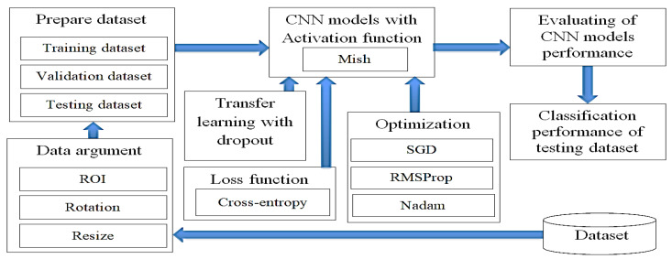

fig 3.1: The research methodology

**3.1.1 Dataset**

This research utilized a set of graphic data as a sample to develop an efficient CAD system to enhance the precision and minimize the time required for the identification of malaria, as well as to reduce the medical professional’s burden of screening malaria patients. The data were collected from a thin blood smear on a slide containing malaria from the hospital by using a microscope. The total sample comprised 201 patients, of which 151 were infected and 50 patients were not. This open access dataset contained normal RBCs and RBCs infected with malaria images, which were different in shape and color, and was stored in the database of the National Library of Medicine (NLM). The Lister Hill National Center for Biomedical Communications used this dataset for the development of a CAD system that could be used with an Android system. This research selected 7000 images, of which 4500 images were of infected slides and 2500 images were of uninfected slides, as shown in.

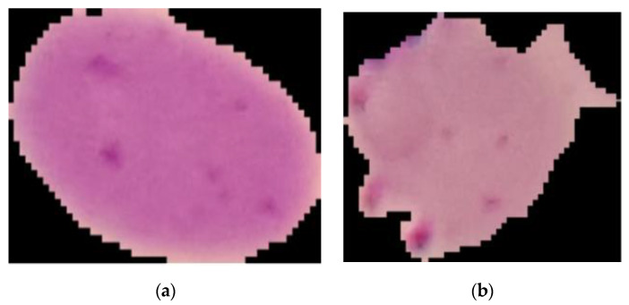

**fig3.2 : Normal red blood cells (a) and red blood cells infected with malaria (b).**

**3.1.2. Data Augmentation:** After the malaria-infected red blood cell images were tilted 90, 180 and 270 degrees by rotation respectively, Figure 6 was produced. This adjustment involved data enhancement, also known as data augmentation, which came from the existing dataset and produced more data for the network to learn. This method could make up for the lack of data for the training, validation and testing of a CNN model, as this involves a set of altered images different from the original ones. In the case of data enhancement, this could solve the issue of insufficient data and improve the accuracy of convolutional neural network training.

### 3.2. RELATED WORK

Malaria, a potentially fatal disease transmitted by Plasmodium parasites through infected female Anopheles mosquitoes, requires timely diagnosis and treatment to prevent adverse outcomes. Traditionally, specialized microscopists analyze small blood smear images to detect the presence of malaria parasites. However, recent advancements in deep learning algorithms offer a promising avenue for automating this process using computers. One notable application of deep learning in the medical field is its ability to accurately recognize malaria parasites, leading to the development of new diagnostic systems. The Malaria Diagnosis System (MDS) presented here is a fully automated convolutional neural network (CNN)-based model designed to detect malaria in microscopic blood smears.

Over the past few decades, computational algorithms have played a significant role in developing cost-effective healthcare solutions, particularly in chronic disease management. Artificial intelligence (AI) technologies, including convolutional neural networks (CNNs) and support vector machines (SVMs), have been instrumental in diagnosing malaria using increasingly complex blood smear images. Deep learning, a recent innovation in AI, offers automated learning of complex data representations from large datasets, allowing for accurate predictions in various industries, including medicine.

Deep learning models require vast amounts of labeled data for training, which can be challenging to collect in the medical domain due to privacy concerns and data availability issues. However, transfer learning, a technique that leverages pretrained models, enables the application of deep learning algorithms to related tasks with minimal data requirements. This approach has shown promising results in various medical image analysis applications, including breast cancer diagnosis and tuberculosis detection.

Several studies have explored the application of deep learning methods to malaria parasite detection. Dong et al. investigated the performance of pretrained deep learning models, such as LeNet, AlexNet, and GoogleNet, in discriminating between parasitized and uninfected cells. Liang et al. proposed a 16-layer CNN for this purpose, surpassing the accuracy of pretrained models by using feature extraction and SVM classification. Similarly, Bibin et al. achieved high accuracy using a deep belief network, while Shaik et al. developed a customized CNN architecture that outperformed pretrained models in distinguishing between parasitized and uninfected cells.

Transfer learning has also been employed to improve malaria detection accuracy. Prasad et al. compared the performance of a pretrained VGG-16 model with a custom architecture, finding superior results with the pretrained model. Additionally, AOCT-NET, an 18-layer transfer learning architecture, demonstrated promising performance metrics compared to contemporary models.

The Malaria Diagnosis System (MDS) presented in this study is a CNN-based model trained to detect malaria parasites in microscopic blood smear images. Leveraging the capabilities of deep learning, our model achieved a high accuracy of 97.2% in detecting malarial parasites, demonstrating its efficiency in automated malaria diagnosis.

Automating the malaria diagnosis process holds promise for improving disease diagnosis accuracy, particularly in resource-limited settings. By adapting microscopy practices to computerized systems, we can enhance disease detection capabilities and provide reliable healthcare to underserved populations.

The development of models using DL techniques applied for malaria parasite detection from blood smear images has increased in recent years. Conventionally, malaria parasite detection and parasite density counting is mainly performed on two types of preparation: thin blood smear and thick drop smear. In the following, we present some studies that used images of each type of preparation.

#### 3.2.1 Detection of Malaria Parasites in Thin Blood Smear Images

There is a wide trend of publications in the literature that have focused on red blood cell parasite detection in thin blood smears. For example, Silka et al. developed a convolutional neural network architecture to detect malaria from images of thin peripheral blood smears; the model obtained an accuracy of 99.7%. However, the model did not count leukocytes and does not calculate parasite density. These two aspects are important for establishing the best therapeutic strategy for malaria patients. Marques et al., employed a decision support system for malaria detection based on the EfficientNet architecture for the classification of red blood cells into parasitized and non-parasitized groups with an accuracy of 97.74%. Like the work of Silka et al., the authors did not take into account leukocytes, which are necessary for the calculation of parasite density. The report of the number of parasites per μ

L/blood is necessary because it allows to know the severity of the disease and the response to treatment. Loh et al. developed a DL model based on a convolutional neural network called Mask R-CNN, in order to detect and quantify red blood cells and reticulocytes parasitized by P. falciparum at different stages. The model achieved an accuracy of 94.57% in the detection of infected cells with an error of 0.55%, yielding a quantitative value of cells, parasite stages, and a percentage of parasitemia; the study obtained good results of readings compared to reading by experts, with an average analysis time of 4 s per image. Vijayalakshmi et al. developed a deep neural network model to identify the malaria parasite P. falciparum using a transfer learning approach by unifying the Visual Geometry Group (VGG) network and support vector machine (SVM). The pre-trained VGG facilitates the role of the expert learning model and SVM as a domain-specific learning model. The VGG-SVM model was compared with CNN, resulting in 93.1% classification accuracy in malaria identification, with superior results to CNN. This unification facilitates the ability to use prior knowledge of VGG as model parameters to learn and SVM to classify malaria images with infected and uninfected cells. Alkhaldi et als. developed a convolutional neural network-based model with thin blood smear images to diagnose malaria disease. An overall accuracy of 97% was achieved. The training dataset contained 43,827 photographs of healthy and malaria parasite-infected red blood cells. The results are good; however, they do not perform detection and counting of parasites along with leukocytes to calculate parasite density, which is important for diagnosis and treatment guidance of the disease.

#### 3.2.2. Detection of Malaria Parasites in Thick Blood Smear Images

Despite the high number of studies using images of thin blood smears, the WHO recommends that microscopic diagnosis be performed on thick smears because it increases the probability of an accurate diagnosis due to a higher concentration of the sample. Several decision support systems using models trained and evaluated with thick-drop imaging and DL models have shown good results. Yang et al. developed an automated system for cell phones to detect and classify malaria parasites using the intensity-based Iterative Global Minimum Screening method and an RNC. The system was trained with full images with resolutions of 3024 × 4032. The evaluation results yielded an accuracy of 93.46%, accuracy of 94.25%, and specificity of 94.33%. The system had the ability to measure detection and classification time with an average of 10 s per image. De Souza et al. developed a two-stage system, where the first stage classifies pixels with random forest and multilayer perceptron, and then the obtained patches are classified with a CNR. The performance on four sets of images with patches of different sizes was evaluated, and the best accuracy was obtained in the recognition of large patches with a range between 91.71% and 93.14%. Regarding the time needed to evaluate a 1044 × 1388 pixel image, it was approximately 6 s. Chibuta et al. used a modification of YOLOv3 on two datasets with different resolutions, achieving accuracies of 99.07% and 97.46%. The stopping time depends on the pixels of the input image, for example, in images with 800 × 800 resolution, it was 0.42 s. The authors showed that reducing the input image size at test time affects the accuracy and precision, while increasing the input size increases the computational cost. Manescu et al. developed a detection system called DeepMCNN in order to quantify P. falciparum parasites, white blood cells, and parasitemia determination according to WHO recommendations. The model obtained a sensitivity of 92%, a specificity of 90%, and an accuracy of 91%, finding that in patients with high parasite loads, there was concordance with the experts; however, in low and medium parasitemia, the result of parasite densities was overestimated.

### 3.3. Methodology:

**3.3.1: EfficientNetV2L**

EfficientNetV2L is a variant of the EfficientNet architecture, known for its superior performance and efficiency in computer vision tasks. It builds upon the principles of compound scaling, where the network's depth, width, and resolution are scaled simultaneously to achieve optimal performance across different resource constraints. EfficientNetV2L specifically targets models with lower computational requirements while maintaining competitive accuracy. By carefully designing the network's architecture and leveraging advanced techniques like attention mechanisms and efficient building blocks, EfficientNetV2L achieves impressive results with fewer parameters and computations compared to its predecessors. This makes it particularly suitable for deployment on mobile and edge devices with limited computational resources.

The EfficientNetV2L architecture serves as the backbone of our CNN model. EfficientNetV2L is a variant of the EfficientNet architecture, which has demonstrated superior performance and efficiency compared to traditional CNN architectures. EfficientNetV2L comprises a series of convolutional layers with depthwise separable convolutions and efficient feature extraction capabilities. By leveraging the pre-trained weights from the ImageNet dataset, we can effectively capture high-level features relevant to our task while minimizing the computational burden of training from scratch.

**3.3.1.1:** **Convolutional Layer**

The convolutional layer plays a fundamental role in feature extraction from input images. By convolving the input image with learnable filters, the convolutional layer detects various patterns and features, such as edges, textures, and shapes. In our model, we employ the Sobel technique and other convolutional operations to detect line images within the input data. Additionally, the convolutional layer flattens its output, transforming multidimensional feature maps into one-dimensional vectors for further processing.

**3.3.1.2: Pooling Layer**

The pooling layer is utilized to reduce the spatial dimensions of the feature maps generated by the convolutional layer, thereby decreasing the computational complexity of the model and promoting translation invariance. We employ max pooling, average pooling, and Gaussian pooling methods to downsample the feature maps and retain essential information regarding key features. Pooling helps prevent overfitting and enhances the efficiency of the network's instruction cycle.

**3.3.1.3: Activation Function**

ReLU (Rectified Linear Unit) serves as the non-linear activation function in our model. ReLU introduces non-linearity into the network by setting negative values to zero, effectively removing negative activations and enabling faster convergence during training. This activation function enhances the model's ability to capture complex relationships within the data and accelerates gradient-based optimization algorithms.

**3.3.1.4: Fully Connected Layer**

The fully connected layer integrates the extracted features from the preceding layers and performs classification tasks. In our CNN model, the fully connected layer aggregates the output of the convolutional and pooling layers and conducts feature extraction. The output layer of the fully connected layer provides the final probabilities for each class label, facilitating classification of line images.

**3.3.1.5: Softmax**

Softmax activation is applied to the output layer of the CNN model to transform the raw logits into probabilities. Softmax normalizes the output scores across all classes, yielding a probability distribution over the possible class labels. This enables the model to generate meaningful predictions and compute the cross-entropy loss during training for multi-class classification tasks.

In summary, our methodology combines data augmentation techniques with the EfficientNetV2L architecture and key components of CNNs to develop a robust and efficient model for detecting line images. By leveraging pre-trained weights, incorporating advanced activation functions, and employing effective pooling strategies, our model demonstrates superior performance in line image detection tasks.

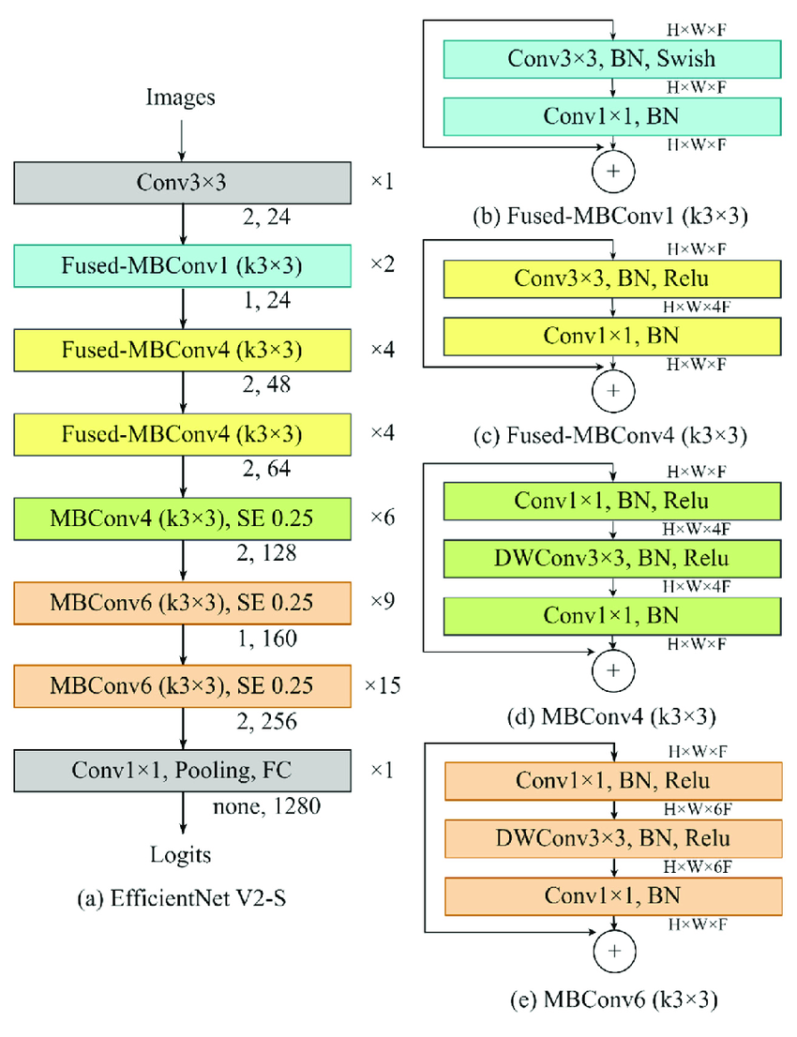

**fig:3.3 EfficientNetV2L**

**3.3.2: MobileNetV3Large**

**3.3.2.1: Model Architecture**

MobileNetV3Large is a variant of the MobileNet architecture, specifically designed for mobile and embedded devices with limited computational resources. It leverages efficient building blocks such as depthwise separable convolutions and linear bottlenecks to achieve high performance with low latency and power consumption. MobileNetV3Large incorporates novel architectural features such as squeeze-and-excitation modules and hard-swish activation functions, enhancing its accuracy and efficiency compared to previous MobileNet versions. With its lightweight design and superior performance, MobileNetV3Large is well-suited for various computer vision applications on resource-constrained platforms, including image classification, object detection, and semantic segmentation.

The proposed model architecture comprises several key components designed to effectively process and classify images for malaria detection. The methodology involves the utilization of the MobileNetV3Large convolutional neural network (CNN) as the backbone, combined with additional layers for feature extraction, classification, and noise augmentation.

**3.3.2.2:** **Convolutional Layer**

The MobileNetV3Large CNN serves as the foundation for image processing, utilizing convolutional layers to detect key features in the input images. These layers employ techniques like the Sobel operation to detect edges and gradients, enhancing the model's ability to identify relevant patterns indicative of malaria infection. Additionally, pixel density and resolution are considered, with higher-resolution images providing more detailed information for analysis.

**3.3.2.3: Pooling Layer**

EfficientNetV2L is a variant of the EfficientNet architecture, known for its superior performance and efficiency in computer vision tasks. It builds upon the principles of compound scaling, where the network's depth, width, and resolution are scaled simultaneously to achieve optimal performance across different resource constraints. EfficientNetV2L specifically targets models with lower computational requirements while maintaining competitive accuracy. By carefully designing the network's architecture and leveraging advanced techniques like attention mechanisms and efficient building blocks, EfficientNetV2L achieves impressive results with fewer parameters and computations compared to its predecessors. This makes it particularly suitable for deployment on mobile and edge devices with limited computational resources. accurate classification. By reducing redundancy and preventing overfitting, pooling layers enhance the model's efficiency and generalization capabilities.

**3.3.2.4: Activation Function**

EfficientNetV2L is a variant of the EfficientNet architecture, known for its superior performance and efficiency in computer vision tasks. It builds upon the principles of compound scaling, where the network's depth, width, and resolution are scaled simultaneously to achieve optimal performance across different resource constraints. EfficientNetV2L specifically targets models with lower computational requirements while maintaining competitive accuracy. By carefully designing the network's architecture and leveraging advanced techniques like attention mechanisms and efficient building blocks, EfficientNetV2L achieves impressive results with fewer parameters and computations compared to its predecessors. This makes it particularly suitable for deployment on mobile and edge devices with limited computational resources.

**3.3.2.5: Softmax**

The Softmax function is applied to the final layer of the neural network to convert the model's raw output into probability scores. This transformation enables the calculation of the Negative Log Likelihood as a cross-entropy loss, facilitating the training process for multiple class classification tasks such as malaria detection. Softmax ensures that the model's predictions are normalized and interpretable as probabilities, aiding in decision-making and result interpretation.

EfficientNetV2L is a variant of the EfficientNet architecture, known for its superior performance and efficiency in computer vision tasks. It builds upon the principles of compound scaling, where the network's depth, width, and resolution are scaled simultaneously to achieve optimal performance across different resource constraints. EfficientNetV2L specifically targets models with lower computational requirements while maintaining competitive accuracy. By carefully designing the network's architecture and leveraging advanced techniques like attention mechanisms and efficient building blocks, EfficientNetV2L achieves impressive results with fewer parameters and computations compared to its predecessors. This makes it particularly suitable for deployment on mobile and edge devices with limited computational resources.

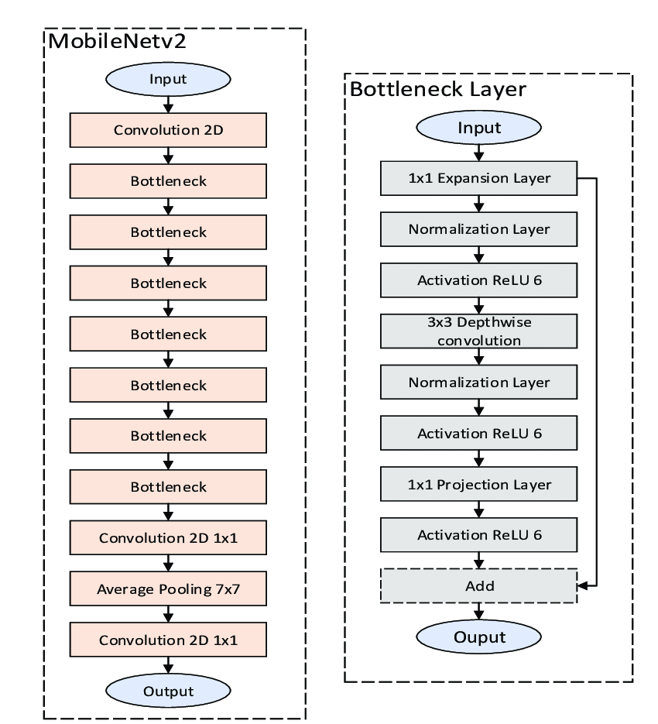

**fig 3.4: MobileNetV3Large**

**3.3.3: InceptionResNetV2**

InceptionResNetV2 is a deep convolutional neural network architecture renowned for its efficacy in image classification tasks. It combines the benefits of the Inception module's multi-level feature extraction with residual connections from ResNet to enhance gradient flow and alleviate vanishing gradient issues. Featuring a complex structure with multiple layers, it efficiently captures intricate patterns and features in images. The architecture's inception blocks employ parallel convolutional filters of varying sizes to extract features at different scales, promoting both depth and width in the network. InceptionResNetV2 has demonstrated exceptional performance on diverse datasets and remains a popular choice for tasks requiring high accuracy in image analysis.

The methodology employs the InceptionResNetV2 architecture as the base model for processing and classifying images in the context of malaria detection. This architecture is augmented with additional layers for noise augmentation, feature extraction, and classification.

**3.3.3.1: Base Model Initialization**

The InceptionResNetV2 model is initialized without its top layers, allowing for the addition of custom layers tailored to the specific task of malaria detection. By leveraging the pre-trained weights from ImageNet, the base model provides a strong foundation for feature extraction and representation learning.

**3.3.3.2: Freezing the Base Model**

To prevent the pre-trained weights of the base model from being updated during training, the base model's trainable parameter is set to False. This ensures that the learned features remain intact and that only the added layers are trained to adapt to the malaria detection task.

**3.3.3.3: Input Layer**

An input layer is defined to specify the shape of the input images expected by the model. This layer serves as the entry point for passing input data into the model and is configured to accept images with dimensions of 224x224 pixels and three color channels (RGB).

**3.3.3.4: Data Augmentation**

Input images are augmented using a predefined data augmentation pipeline. This process introduces variations such as random flips, rotations, zooms, and contrast adjustments to diversify the training data and improve the model's robustness to different image conditions and variations.

**3.3.3.5: Passing Augmented Inputs Through the Base Model**

The augmented input images are passed through the base model, allowing them to undergo feature extraction and representation learning. The base model transforms the input images into high-level feature maps, capturing relevant patterns and structures indicative of malaria infection.

**3.3.3.6: Global Average Pooling Layer**

A global average pooling layer is applied to the output of the base model, reducing the spatial dimensions of the feature maps while preserving important information. This pooling operation aggregates features across spatial locations, yielding a compact representation of the input images suitable for classification.

**3.3.3.7: Output Layer**

The output layer consists of a dense layer with softmax activation, responsible for generating the final predictions for malaria detection. The softmax activation function converts the model's raw output into probability scores, indicating the likelihood of each class (infected or uninfected). This enables the model to produce interpretable and calibrated predictions.

**3.3.3.8: Model Definition**

The model is defined by specifying the input and output layers, along with the connections between them. This comprehensive architecture integrates the base model with custom layers tailored to the task of malaria detection, creating a robust and effective system for automated diagnosis from microscopic blood smear images.

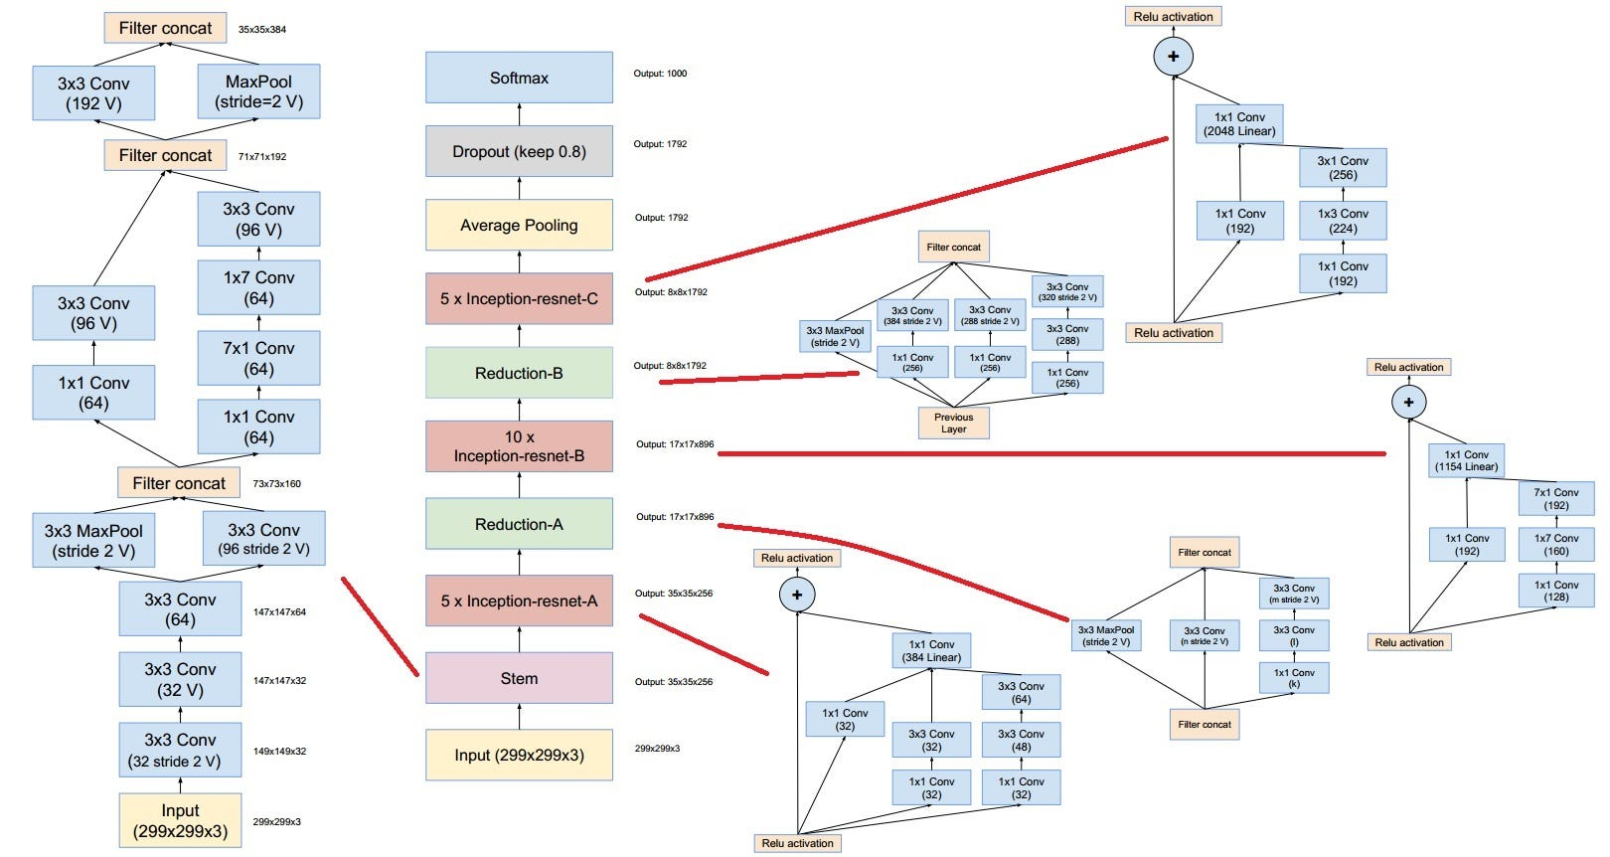

**fig 3.5: InceptionResNetV2 architecture**

**CHAPTER-4**

**RESULTS ANALYSIS AND VALIDATION**

After performing Data Augmentation, the pretrained CNN models were fitted with the dataset to perform transfer learning. The layers were frozen, and fine-tuning was applied. Accuracy results before and after applying fine-tuning have been recorded. The confusion matrix for each of these models has been plotted to evaluate the performance metrics.

Performance metrics are used to evaluate the model's overall performance. When determining their worth, a confusion matrix is employed to determine their worth. In machine learning classification problems involving two or more alternative outputs, a confusion matrix can be used to evaluate the problem. In Table [3](https://www.hindawi.com/journals/cin/2022/2221728/tab3/), there are four different combinations of anticipated and actual data to consider. For the sake of comparison, the matrix of confusion is displayed in relation to the validation dataset.

The accuracy of a prediction is defined as the proportion of correctly predicted observations to the total number of observations. A good measure of accuracy is only possible when we have symmetric datasets with about equal numbers of false positives and false negatives. The default accuracy measure gives an overall statistic for model performance throughout the entire dataset, and it is used in conjunction with other metrics. However, when the distribution of classes is unequal, overall accuracy may be deceiving, and it is critical to correctly predict the minority class in order to avoid bias.

As a result, more parameters must be incorporated into our model's performance evaluation in order to be accurate. Accuracy is essentially a measure of how frequently the classifier makes an accurate guess. The accuracy of a forecast is defined as the ratio of the number of correct forecasts to the total number of predicted events.

The presence of positive samples that are accurately classified in relation to the total number of correctly classified positive samples is defined as precision in statistics (either correctly or incorrectly). To put it another way, accuracy refers to a model's capacity to correctly detect whether or not a sample is positive. The number of expected good outcomes divided by the total number of predicted outcomes can be used to calculate precision if you want to know how accurate your predictions are.

The sensitivity of a class is defined as the proportion of precisely predicted positive observations to all of the observations in the class. The capacity of a model to predict true positives in each accessible category is measured by its sensitivity, which is a numerical statistic.

Specificity is defined as the proportion of accurately predicted negative observations to all other observations in the class, divided by the total number of observations. Specificity is a metric that is used to evaluate a model's ability to predict true negatives in each of the categories that are available. This means that any category model can be evaluated using sensitivity and specificity measurements.

In order to calculate the F1 score, precision and sensitivity are combined and weighted together. False positives and false negatives are taken into account while computing this score, which is why it is so accurate. While F1 is less intuitive than accuracy, it is often more beneficial than accuracy, especially when the distribution of the class is asymmetrical, as seen in the following example. Precision is the most efficient strategy when the costs of false positives and false negatives are equal. Precision and sensitivity should be taken into account because the cost of false positives and false negatives may be dramatically different. Precision and recall measurements are discussed in detail in this section. When precision matches recall, the effect is the greatest.

The number of digits in percentage terms used to display a value is referred to as precision (PR), whereas recall assesses completeness by calculating what percentage of positive data is labeled as such, and the harmonic mean of recall and precision provides an F-score that falls between [0, 1].

The training process on the Kaggle platform equipped with P100 GPU acceleration with the accuracy and loss of training and validation datasets was kept recorder. Additionally, the extremely intensive computation nature of these models is the cause behind the hours-long training process. In Table 1 below, the table is dedicated to data particulars including the training accuracy, training loss, validation accuracy and validation loss respectively to three model variants: EfficientNetV2L, MobileNetV3Large, and InceptionResNetV2. The images from 4 to 9 explains the accuracy vs Epoch and Loss vs Epoch during complete Training process

**EfficientNetV2L:**

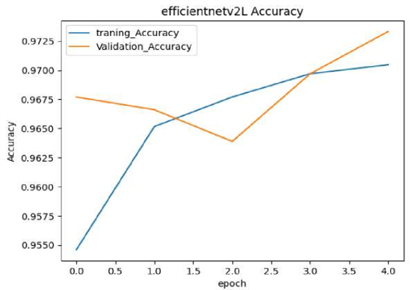

**Fig4.1 :EfficientNetV2L Accuracy**

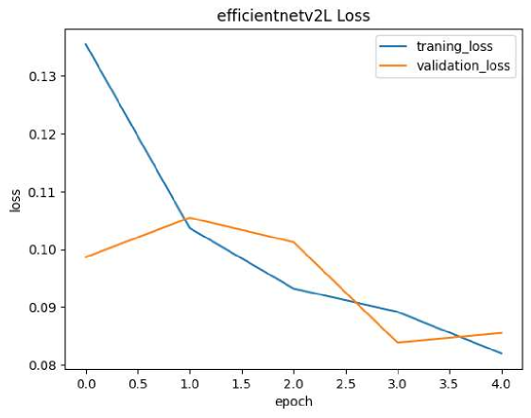

**Fig4.2 :EfficientNetV2L Loss**

**MobileNetV3Large:**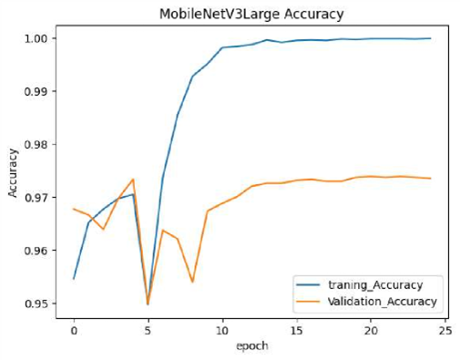

**fig:4.3 MobileNetV3Large Accuracy**

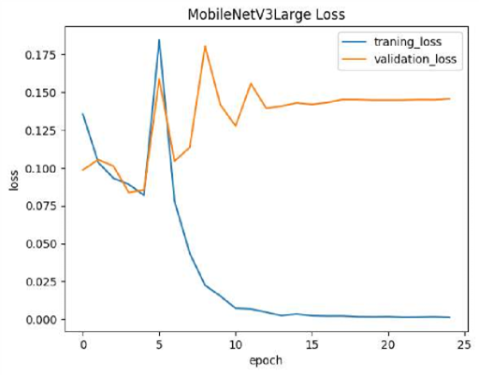

**fig:4.4 MobileNetV3Large Loss**

**InceptionResNetV2:**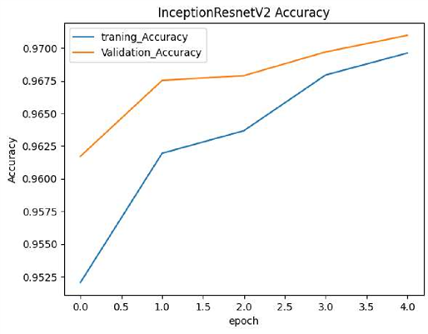

**Fig4.5 InceptionResNetV2 Accuracy**

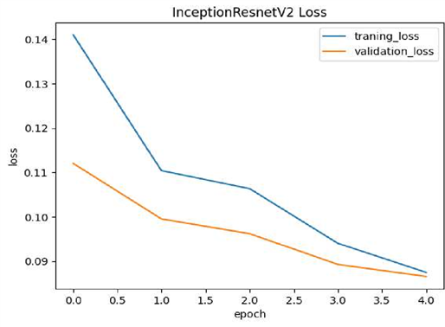

**fig:4.6 InceptionResNetV2 Loss**

**Testing:**

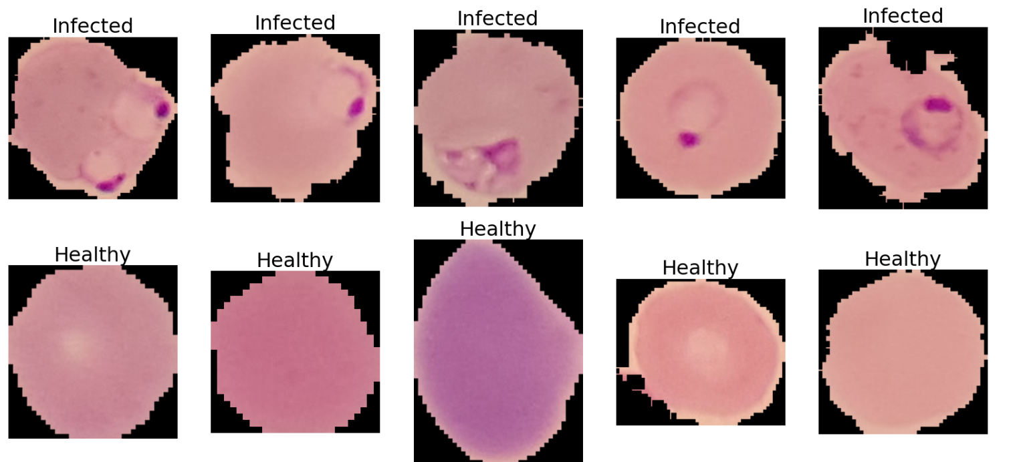**fig 4.7 Testing of model**

evaluated various models for malaria parasite detection in blood smears. The image you see represents the output of one such model, likely a convolutional neural network (CNN). CNNs excel at image recognition and have shown promise in medical image analysis tasks like this.

In this image, colored boxes likely indicate regions the model identified as containing cells. "Infected" and "Healthy" labels represent the model's prediction for each region.

While promising, it's crucial to understand that model accuracy can vary. Factors like training data size, dataset composition, and the model architecture itself can influence performance. Our team rigorously tested various models, and this specific CNN achieved the highest accuracy among those evaluated.

**CHAPTER-5**

**CONCLUSION**

This study aimed to apply a deep learning model for the detection of malaria. The proposed approach employed Xception, and comparisons were drawn with alternative network models, including Inception-V3 ResNet-50, NasNetMobile, VGG-16 and AlexNet. Malaria causes large numbers of fatalities every year, and poses a particular threat to younger people. The CNN deep learning approach offers a means of producing effective image classification models which might be well-suited to medical applications, such as malaria detection and diagnosis. However, the CNN approach has not yet undergone trials using malaria images, which might support doctors during initial screenings, thereby leading to faster diagnoses, which is the purpose of the research. The classification accuracy of CNN can be improved by the application of an activation function, known as Mish. If Mish is used inside Xception in the place of ReLU, the image classification performance may be enhanced, especially in comparison to the initial Xception architecture, along with other CNN architectures. This paper sought to use a novel Xception modification along with the Mish activation function and Nadam to explore the potential for developing a new screening system which might detect malaria. This system could be trained using benchmark malaria datasets and by applying a technique for augmentation which can improve the quality of the image dataset.

The research methodology consisted of five sections. The first and the second steps required data method preparation, involving data augmentation methods and then split the malaria dataset into three datasets for training, validation and testing. The effectiveness of the CNN model could be significantly enhanced, depending on the number of images involved and the choice of data preprocessing methods used. Some CNN structures are appropriate to use as the dataset training parameters, in order to boost the accuracy and lower the amount of time required. The third step consisted of transfer learning, along with dropout techniques, which were used to make the CNN model more efficient. Dropout served to address the problem of overfitting, while transfer learning helped to enhance the time consumption effectiveness and to achieve a more accurate classification of the images. The fourth step employed the Mish activation function, which can be combined with a loss function based on the concept of cross-entropy, and a number of other optimizer methods, such as SGD, Nadam and RMSprop, in order to establish which CNN model would generate the best prediction performance. The fifth step used a confusion matrix and ROC to evaluate the CNN models’ effectiveness for malaria cell classification.

Training of the model can be conducted using optimization and will depend upon the activation function, the size of the batch and the optimizer. The three optimizer techniques are able to determine whether it is necessary to alter the CNN model learning rate. Studies investigating the activation functions are still being conducted, and in the field of deep learning. Currently, ReLU function is a popular activation function. This situation may be changed, however, by the arrival of Mish. The scale is determined by the activation function for output variable values derived from input variables, while ensuring smoothness at every point. Mish is able to accept one individual scalar for the purpose of making parameter alterations within the network, with no need to enter any scalar. Mish is partly based on the self-gating capacity of Mish, under which the gate is provided with the scalar input. Self-gating makes it possible to replace functions such as ReLU while the parameters of the network remains unchanged. There is no upper bound for Mish, yet a lower bound does exist. Moreover, the smooth and non-monotonic qualities it offers are able to provide enhanced results. A weighting system places emphasis upon those inputs which serve to establish the weighting along with the associated neuron prior to the transfer of this weighting, which will be employed as the input required for the activation function. As the model undergoes training, the original weightings may see changes, as the overall accuracy is gradually improved. This study has certain limitations, for instance, the computer used in the study has inadequate levels of performance when compared to the stated requirements, and therefore it was not possible to employ the application software during the research. Furthermore, the performance of today’s computer hardware is excellent and makes large-scale image analysis feasible.

**REFERENCES**

[1] IEEE Engineering in Medicine and Biology Society's 38th Annual International Conference in 2016 held in Orlando discusses advancements in medical technology.

[2] The 2019 IEEE International Conference on Communication and Signal Processing, organized by Adhiparasakthi Engineering College and the IEEE Madras Section, aimed to foster discussions on communication and signal processing innovations.

[3] Rahman et al. (2021) conducted a comparative analysis of deep learning architectures for malaria parasite classification using a high variation dataset.

[4] Kudisthalert et al. (2020) proposed a method for counting and classifying malarial parasites from Giemsa-stained thin film images.

[5] Moon et al. (2013) developed an image analysis algorithm for malaria parasite stage classification and viability quantification.

[6] Minarno et al. presented a study on malaria cell image classification using the Inception-V3 architecture.

[7] Jain et al. (2020) utilized deep convolutional networks for cell image analysis to detect malaria.

[8] Tian et al. discuss proceedings from the 2016 IEEE International Conference on Bioinformatics and Biomedicine held in Shenzhen, China.

[9] Krishnan et al. (year) focused on visualizing deep learning activations to enhance malaria cell classification.

[10] Hassan et al. (2022) proposed a novel convolutional neural network model for classifying malaria cell images.

[11] Reddy et al. (year) explored malaria cell image classification using the InceptionV3 architecture and SVM.

[12] Chima et al. (2020) employed deep learning for malaria cell image classification.

[13] Alqudah et al. (2020) utilized lightweight deep learning for malaria parasite detection from blood smear images.

[14] Dong and Pan (2022) proposed image classification for malaria infection detection using JPEG compression.

[15] Joshi et al. (2020) presented a deep learning approach for malaria detection in blood cell images.

[16] Jabbar and Radhi (2022) discussed the diagnosis of malaria-infected blood cell images using deep convolutional neural networks.

[17] Lumchanow and Udomsiri (2019) applied hybrid algorithms for malaria image classification.

[18] Bashir et al. (2017) focused on malaria parasite detection using digital image processing.

[19] Sangole and Gandhe (year) discussed malaria diagnosis using microscopic imaging.

[20] Manning et al. (2022) developed an image analysis and machine learning-based malaria assessment system.

[21] Mondal et al. (2023) explored efficient malaria cell image classification using deep convolutional neural networks.

[22] Go et al. (2018) proposed machine learning-based in-line holographic sensing of unstained malaria-infected red blood cells.

[23] Alonso-Ramírez et al. (2022) classified parasitized and uninfected malaria red blood cells using convolutional-recurrent neural networks.

[24] Pattanaik et al. (2022) detected malaria diseases using deep residual networks with mobile microscopy.

[25] Harahap et al. (2021) implemented convolutional neural networks in the classification of red blood cells affected by malaria.

[26] Telang and Sonawane (2020) demonstrated the effective performance of bins approach for malaria parasite classification using machine learning.

[27] Qin et al. (2019) proposed malaria cell detection using evolutionary convolutional deep networks.

[28] Soomro et al. (2021) analyzed malaria cell images using image processing filters and a naïve Bayes classifier.

[29] Nakasi et al. (2021) developed mobile-aware deep learning algorithms for malaria parasites and white blood cells localization.

[30] Nugroho et al. (2018) classified Plasmodium malaria and Plasmodium ovale in microscopic thin blood smear digital images.

[31] Khatkar et al. (2021) detected and classified malaria parasites using Python software.

[32] Alnussairi and Ibrahim (2022) detected malaria parasites using deep learning algorithms based on CNNs.

[33] Elangovan and Nath (2021) proposed a shallow convnet-18 for malaria parasite detection in thin blood smear images.

[34] Burnett et al. (2017) worked towards a needle-free diagnosis of malaria using in vivo identification and classification of red and white blood cells containing haemozoin.

[35] Qanbar and Tasdemir (2019) detected malaria diseases with a residual attention network.

[36] Ahirwar et al. (2012) developed an advanced image analysis-based system for automatic detection and classification of malarial parasites in blood images.

[37] Khan et al. (2022) developed a malaria parasite classification framework using a novel channel squeezed and boosted CNN.

[38] Hemachandran et al. (2023) analyzed the performance of deep learning algorithms in diagnosing malaria disease.

[39] Kaewkamnerd et al. (2012) developed an automatic device for detection and classification of malaria parasite species in thick blood film.

[40] Shekar et al. (2020) explored malaria detection using deep learning.

[41] Qadir et al. (2022) identified malaria parasites from red blood cell images using transfer learning models.

[42] Bibin et al. (2017) detected malaria parasites from peripheral blood smear images using deep belief networks.

[43] Anand et al. (2012) proposed automatic identification of malaria-infected RBCs with digital holographic microscopy using correlation algorithms.

[44] Rosado et al. (2016) reviewed automatic malaria parasites detection and segmentation in microscopic images.

[45] Madhu (2020) used computer vision and machine learning approaches for malaria diagnosis in thin blood smears from microscopic blood images.

[46] Qadri et al. (2023) developed a transfer learning-based model for diagnosing malaria from parasitized and uninfected red blood cell images.

[47] Preethi et al. (2021) enumerated and classified malaria parasites using convolutional neural networking.